**Header**

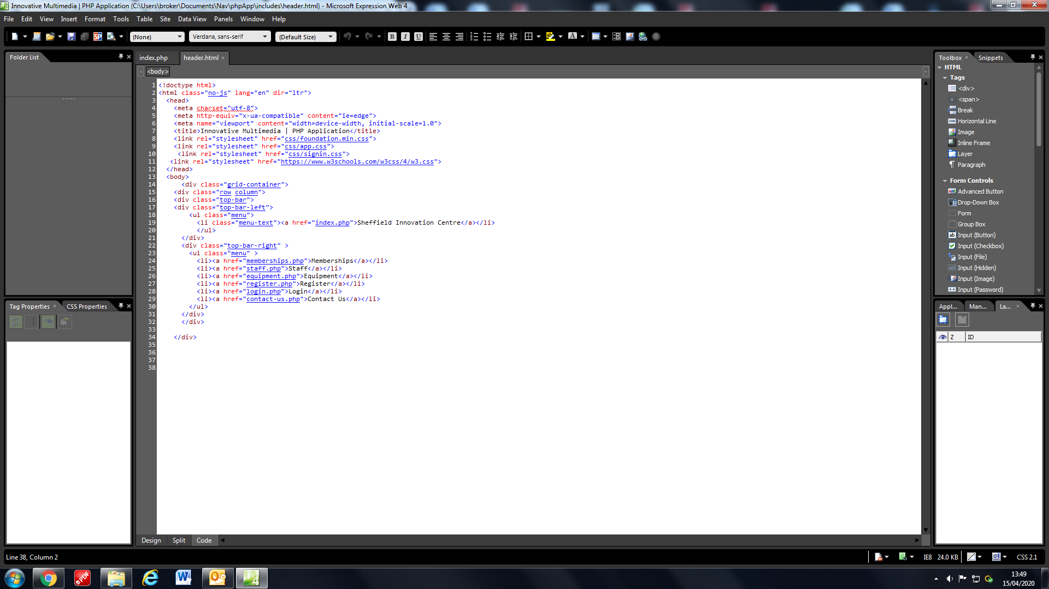

This functionality is part of the header.html file, it is included in all files using php and it serves as the navigation bar of the site. As we created more pages, we added to the list in the menu class which links you to other pages.

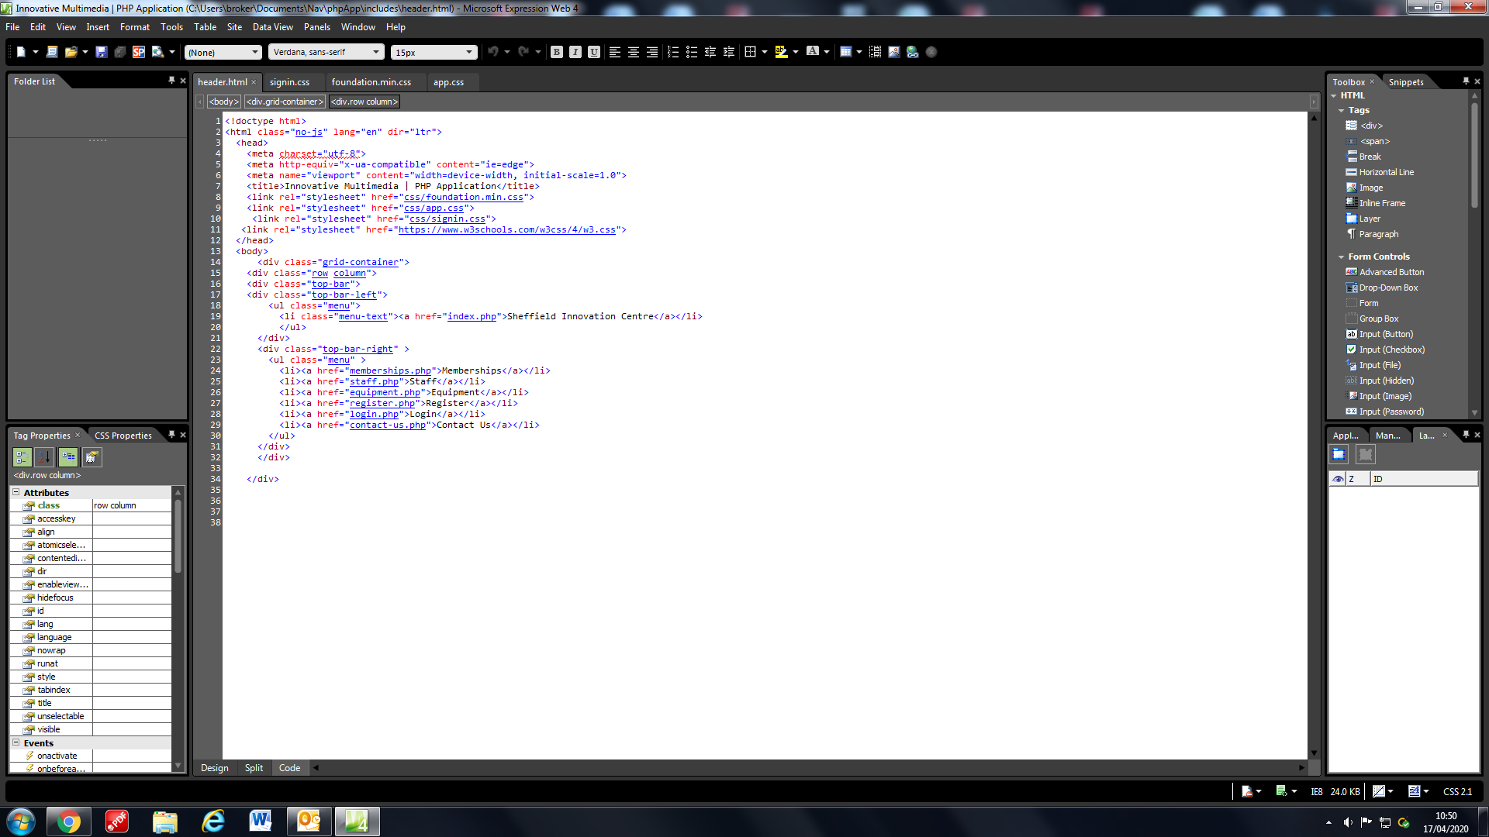

Linked all the css files in order to create the look of the website, originally the header looked like this.

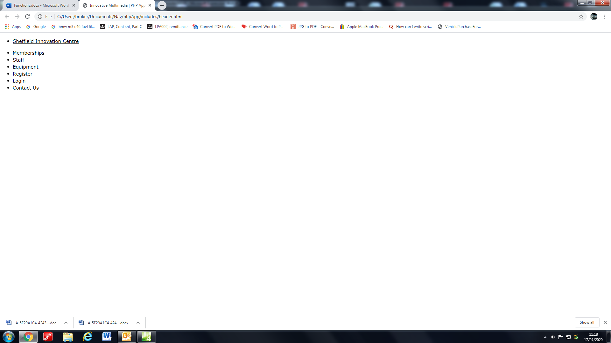

Then with the css files within the css folder it turned to this.

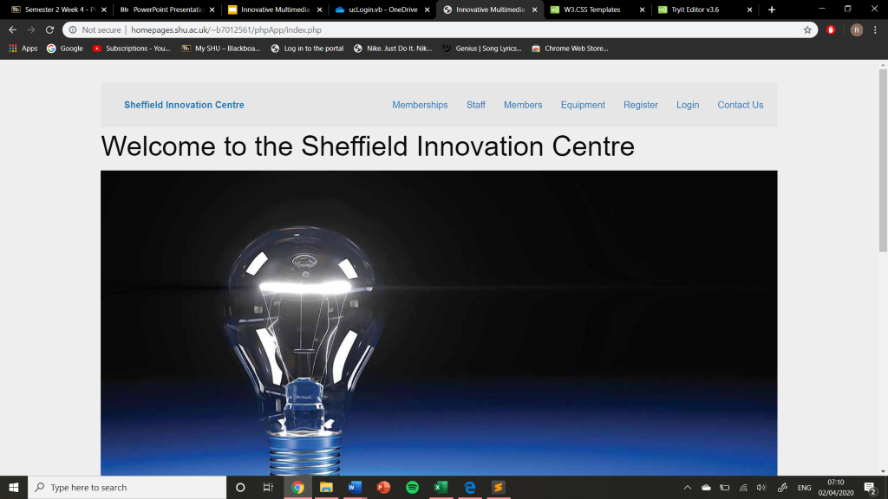

And by using some online help we managed to create a new theme for the website using <https://www.w3schools.com/w3css/4/w3.css>

When this combined with what we had already it created a slick grey design that looked better, is easier to navigate and is more in line with the gyms theme.



**Footer**

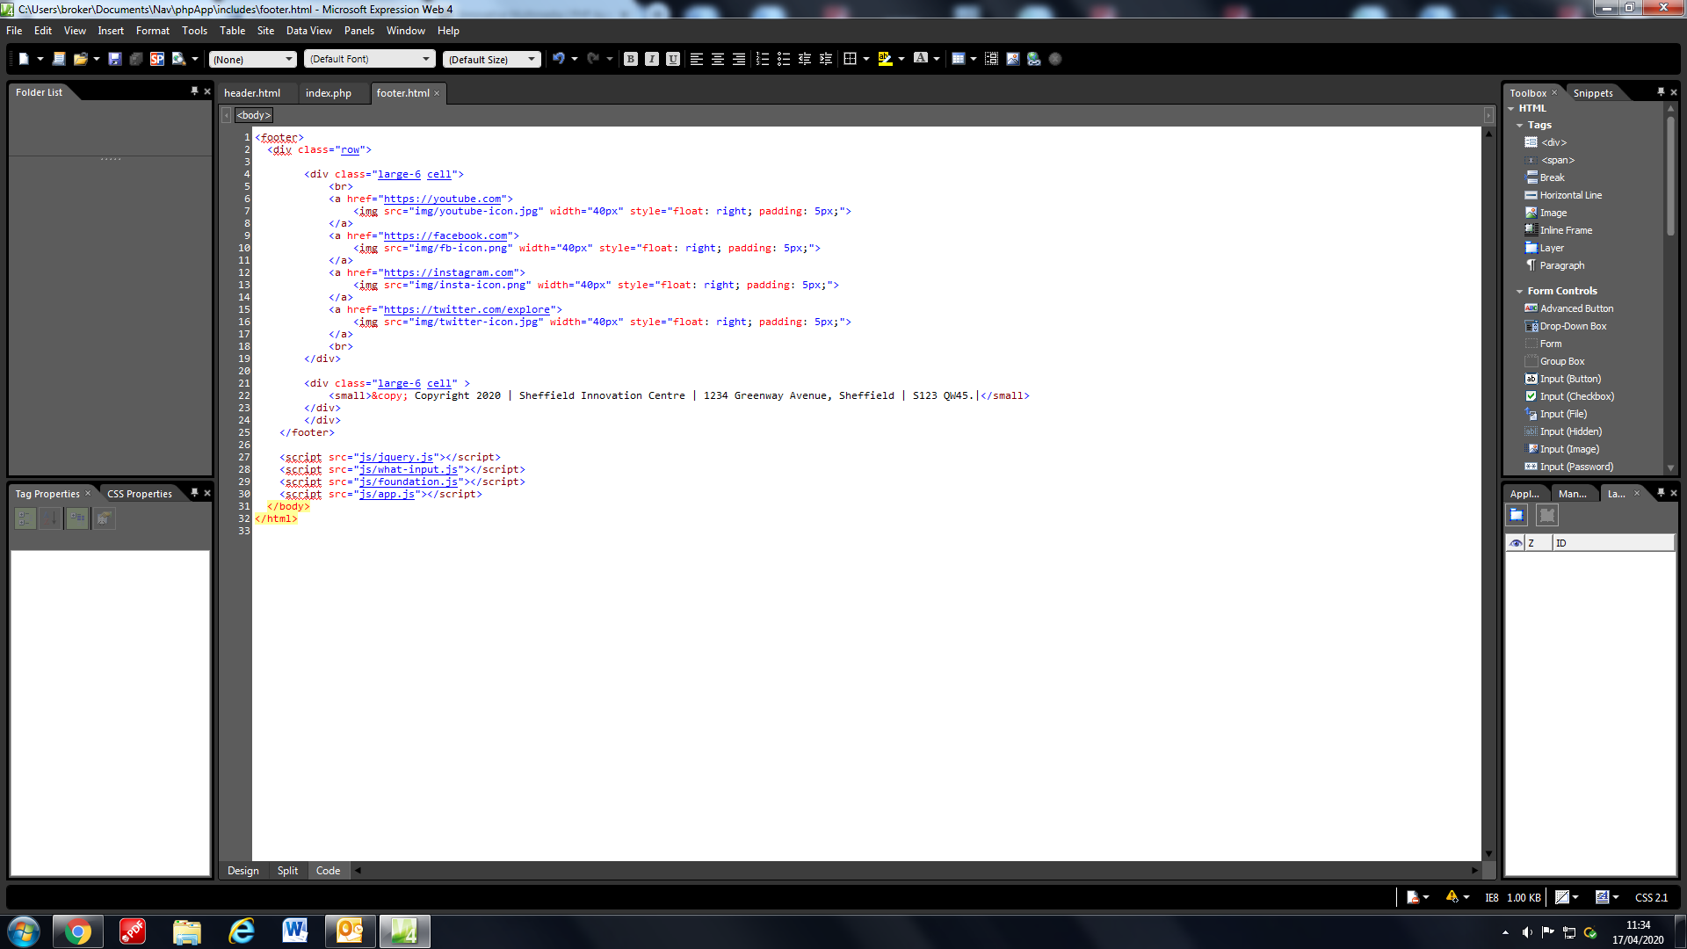The footer like the header is also included on every page, it serves two purposes for the website. The first is to inform the users of the address and rights of the gym whilst the other is to add a social media aspect to the gym and using html and some css in order to move it to the right side are links to all of our social media pages.

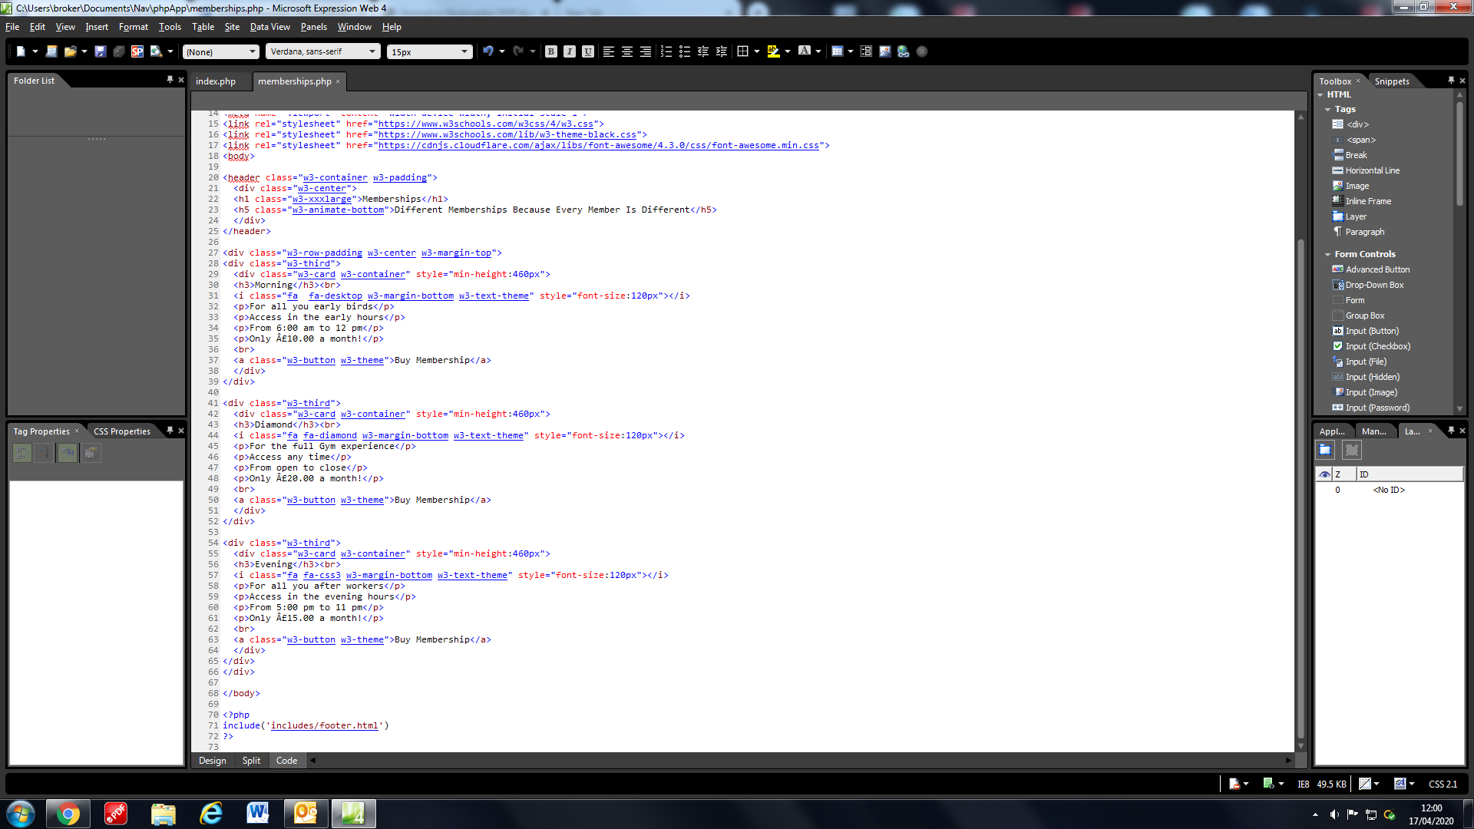

How the footer is added to a page, placed at the bottom of all pages.

**Home and Admin Header**

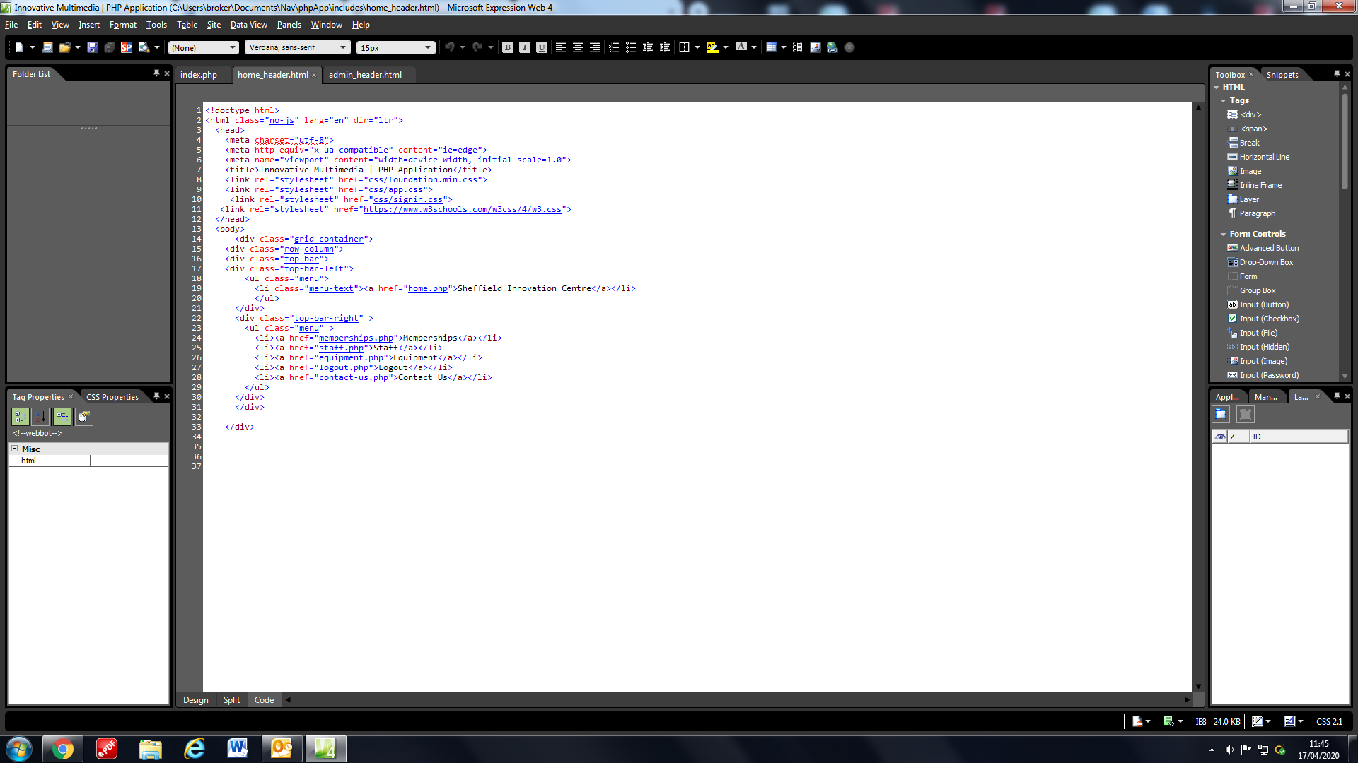

The home header replaces the original header when a user logs in.

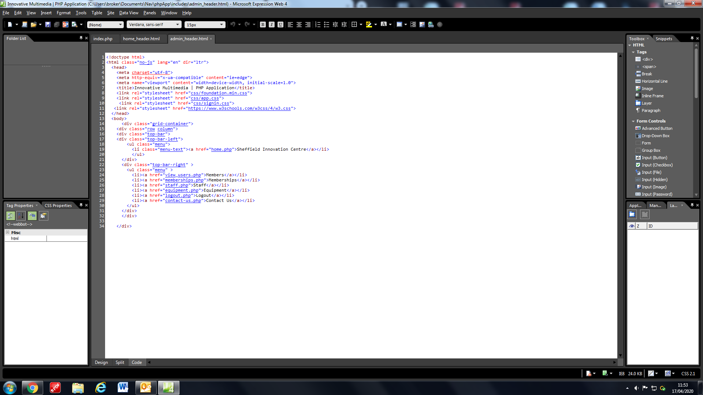

And the admin header replaces the header when an admin account logs in. They both have different pages that they can and cannot access.

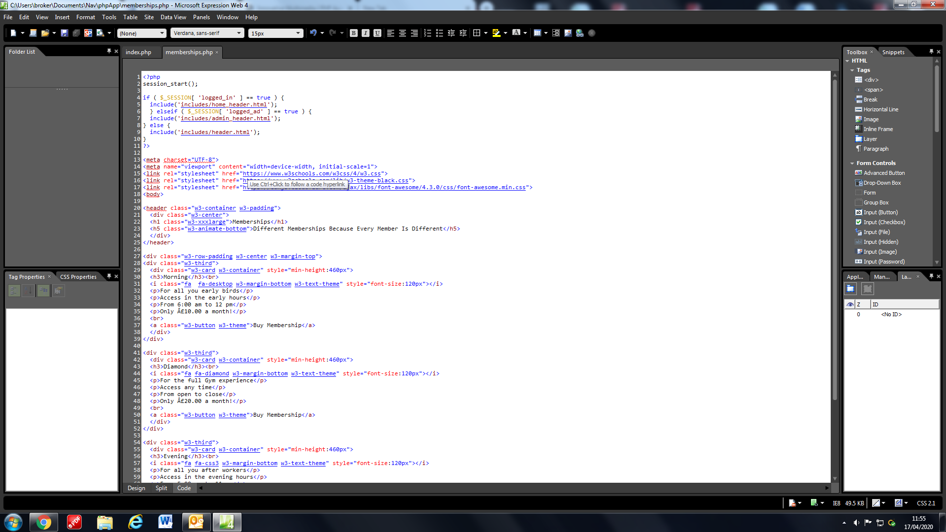

By implementing this php if statement at the start of the pages in the website it allows us to switch between different headers. Using two global boolean variables when you login it switches the value to true and thus when you click on a page it checks if the variable is true so it can load that certain header. If none are true then it just loads the normal header.

**Adding Images**

Images are an important part of any website to make it more visually pleasing to the user.

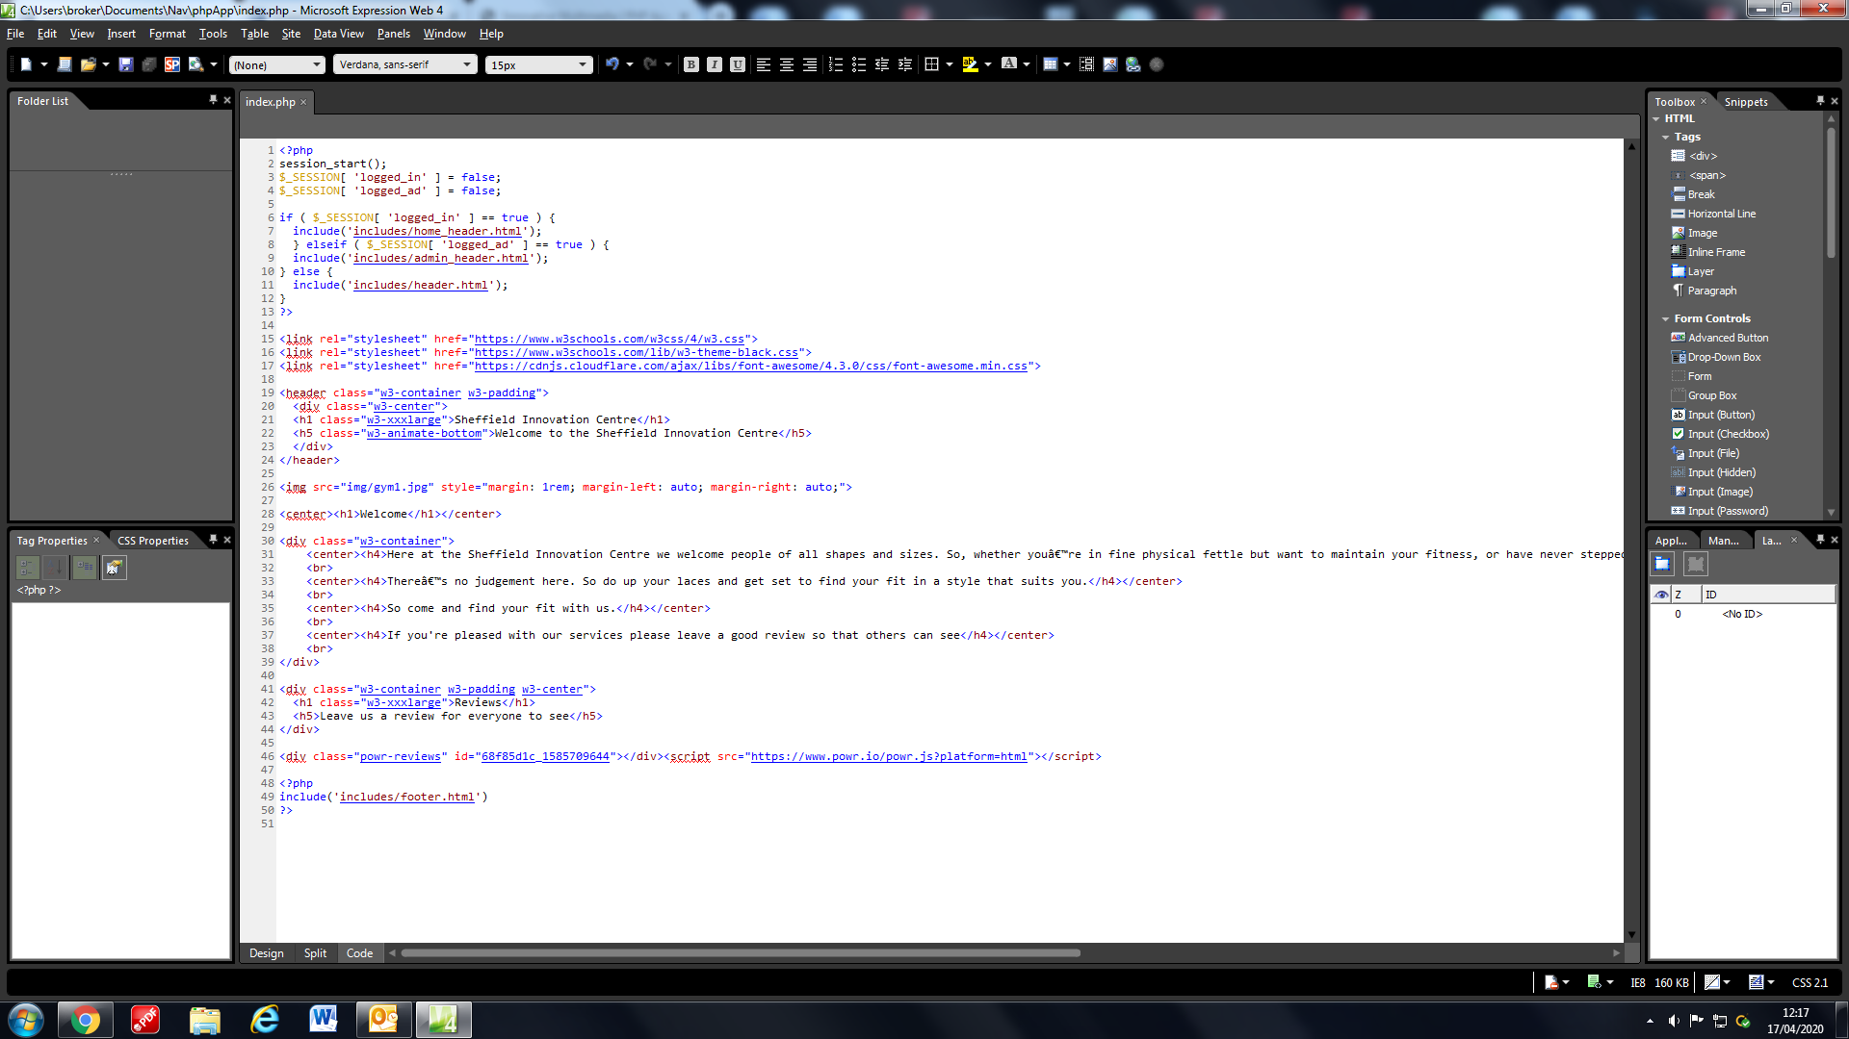

HTML Img src gives the link to the image whilst the style part uses css to make sure it is centre and has a gap all around its edges. Rem is better to use in css instead of pixels since it accommodates for different screen sizes. The smaller your screen the smaller rem becomes and vice versa therefore making viewing on all devices better.

**Adding Reviews**

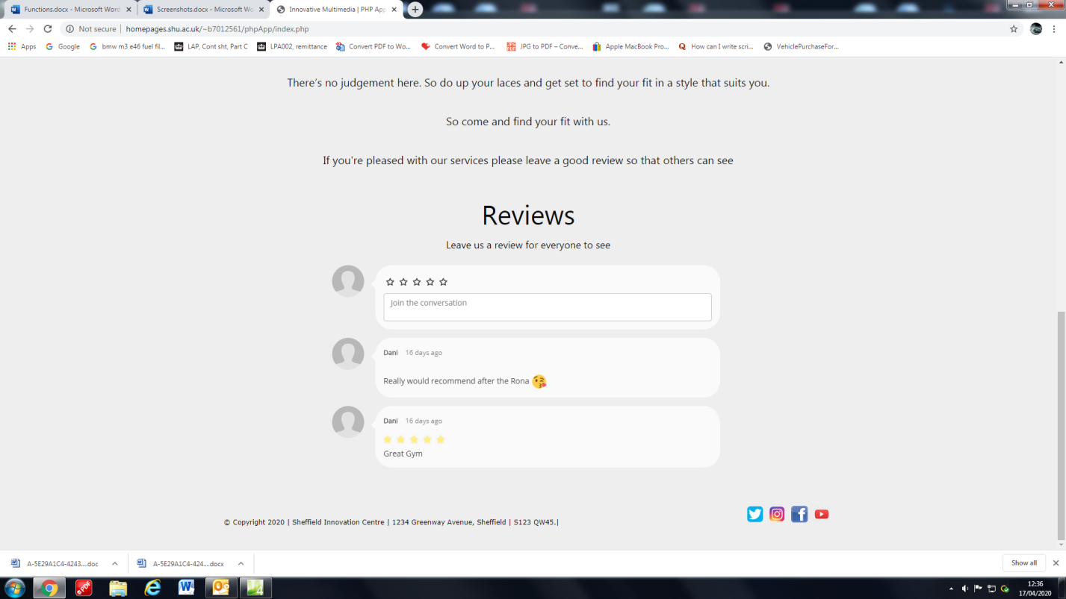

Adding reviews was pretty simple it was simply just a plugin that was found online.

By using <https://www.powr.io/tutorials/how-to-add-reviews-plugin-to-your-html-site>

They did most the work by implementing their reviews system into the website. After setting it up all we had to do was add the class and id that was told of us as well as the link using JavaScript in order for it to appear on the website. You can manage all comments on the website therefore giving you full control of the reviews.

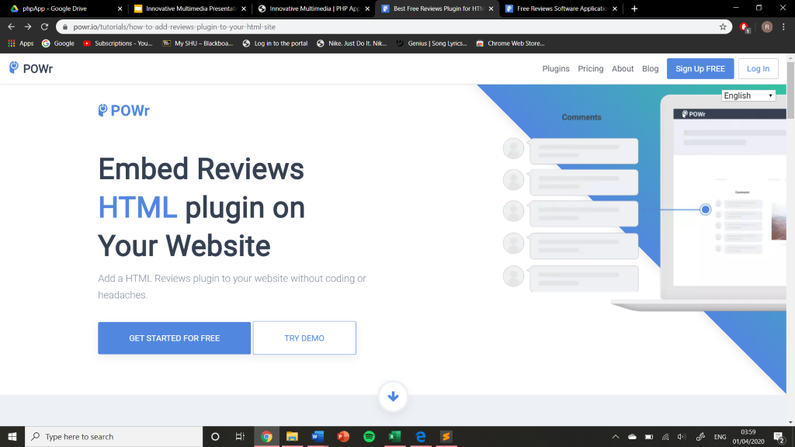

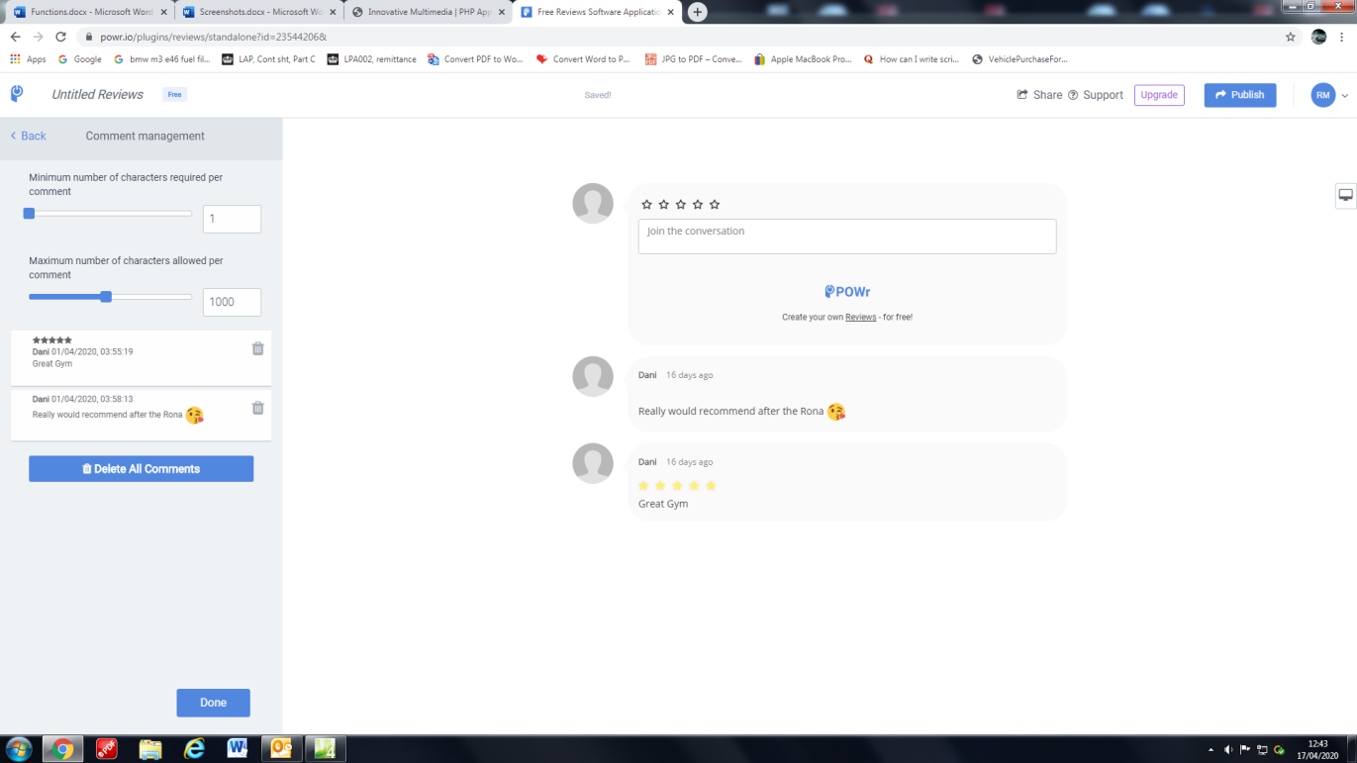

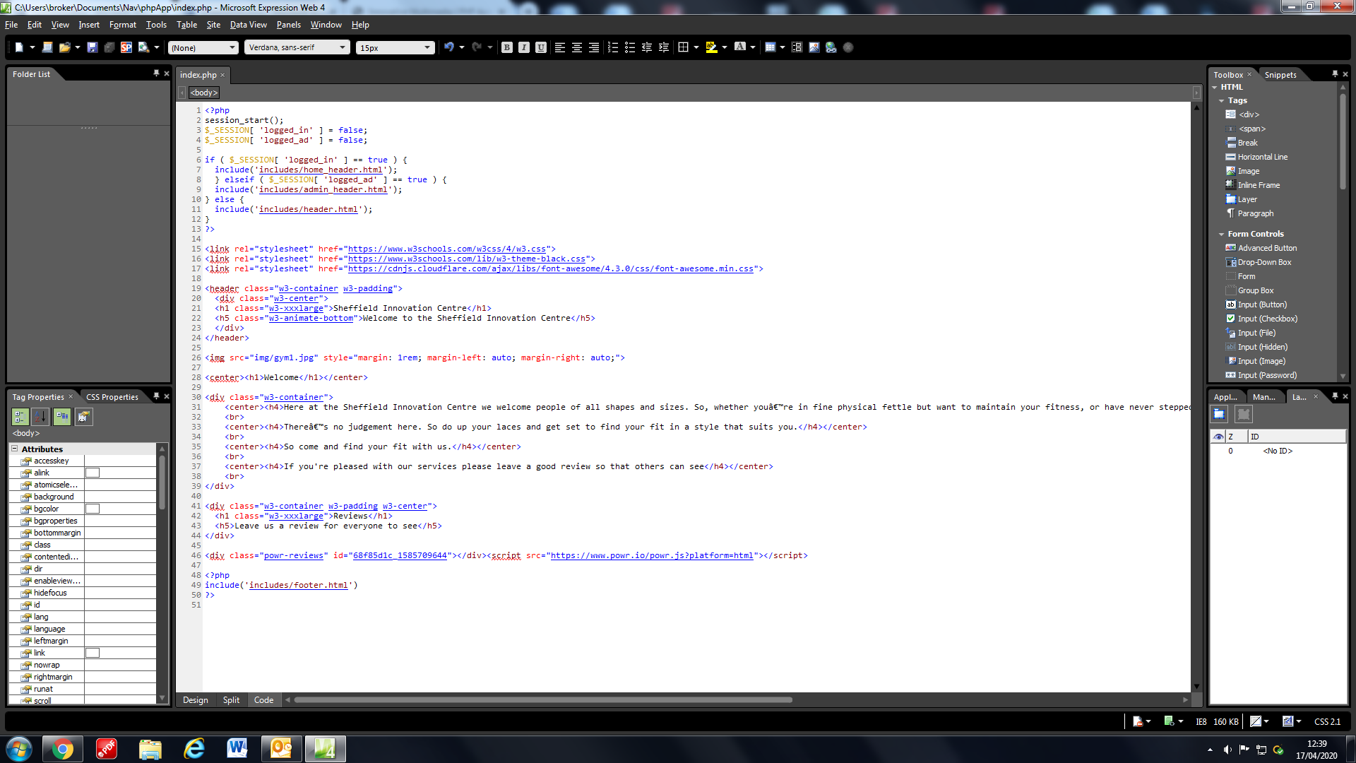

**Connecting To A Database**

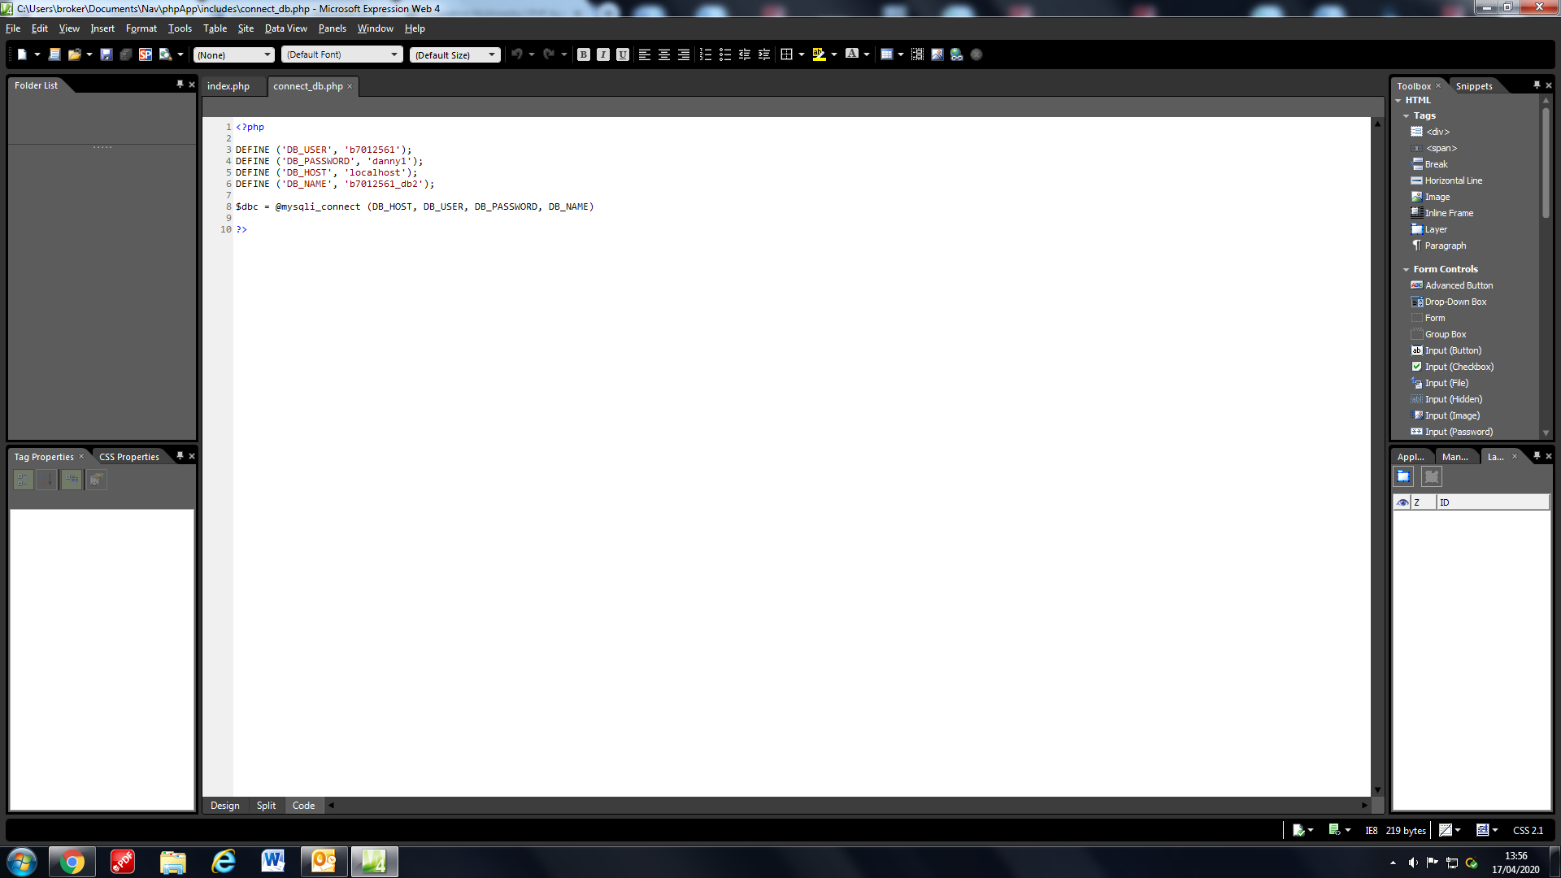

<http://homepages.shu.ac.uk/mysql/index.php>

We used the following PHP to connect to our database saved with SHU PhpMyAdmin this allowed us to create a database with all the users that get added in the registration page as well as the admin users.

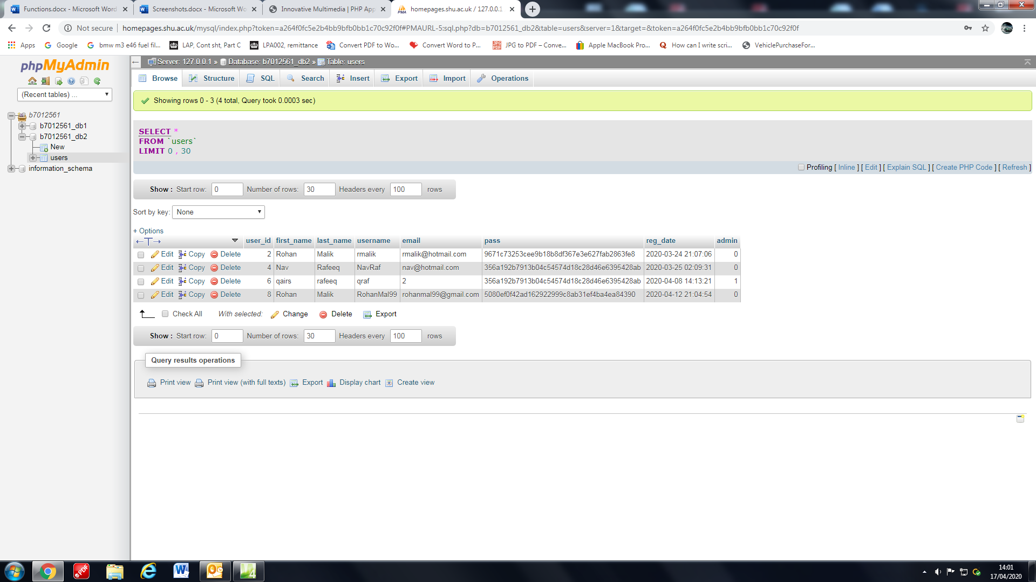

This code establishes the connection with the b7012561_db2 database and allows us to access the tables within. It is saved in the includes folder along with the headers and footer so that it can be used whenever the page needs to connect to the database.

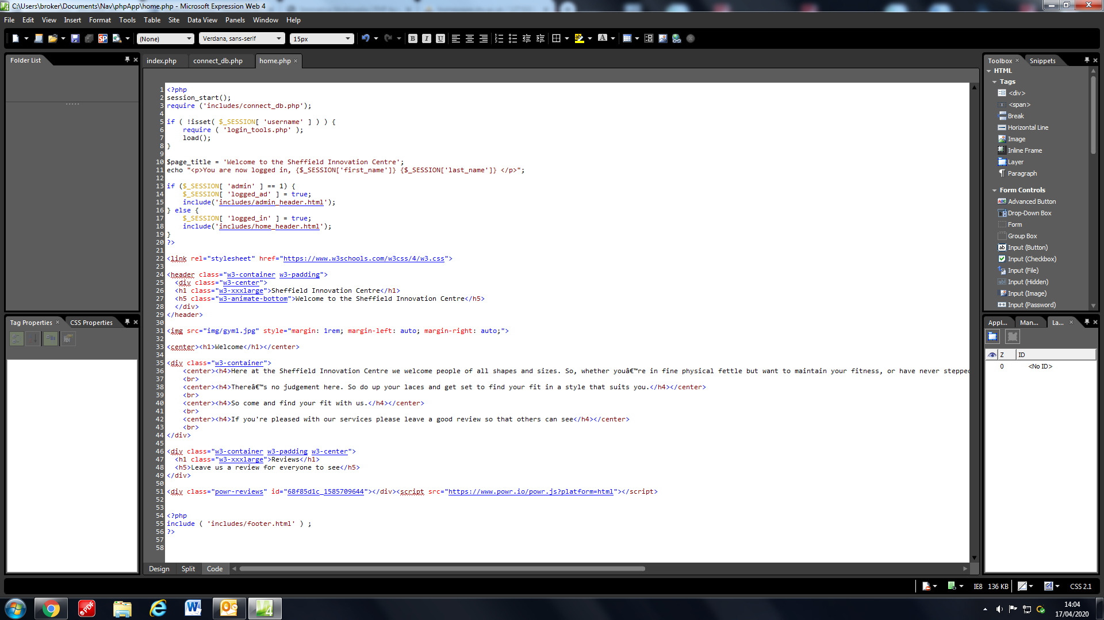

**Home Page**

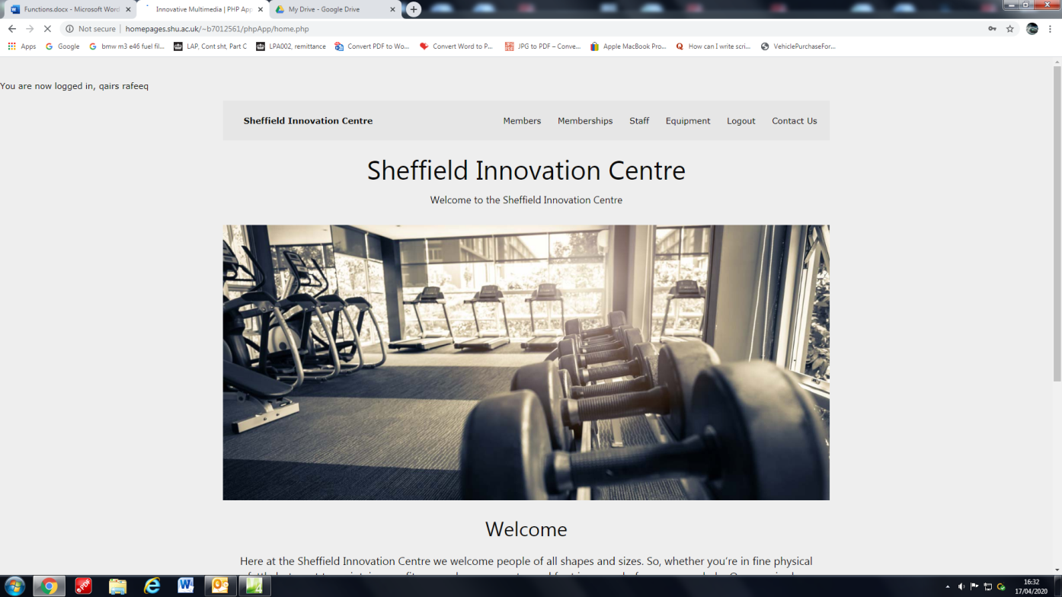

The home page is the same as the Index page however it has a bespoke login message for the user who logs in.

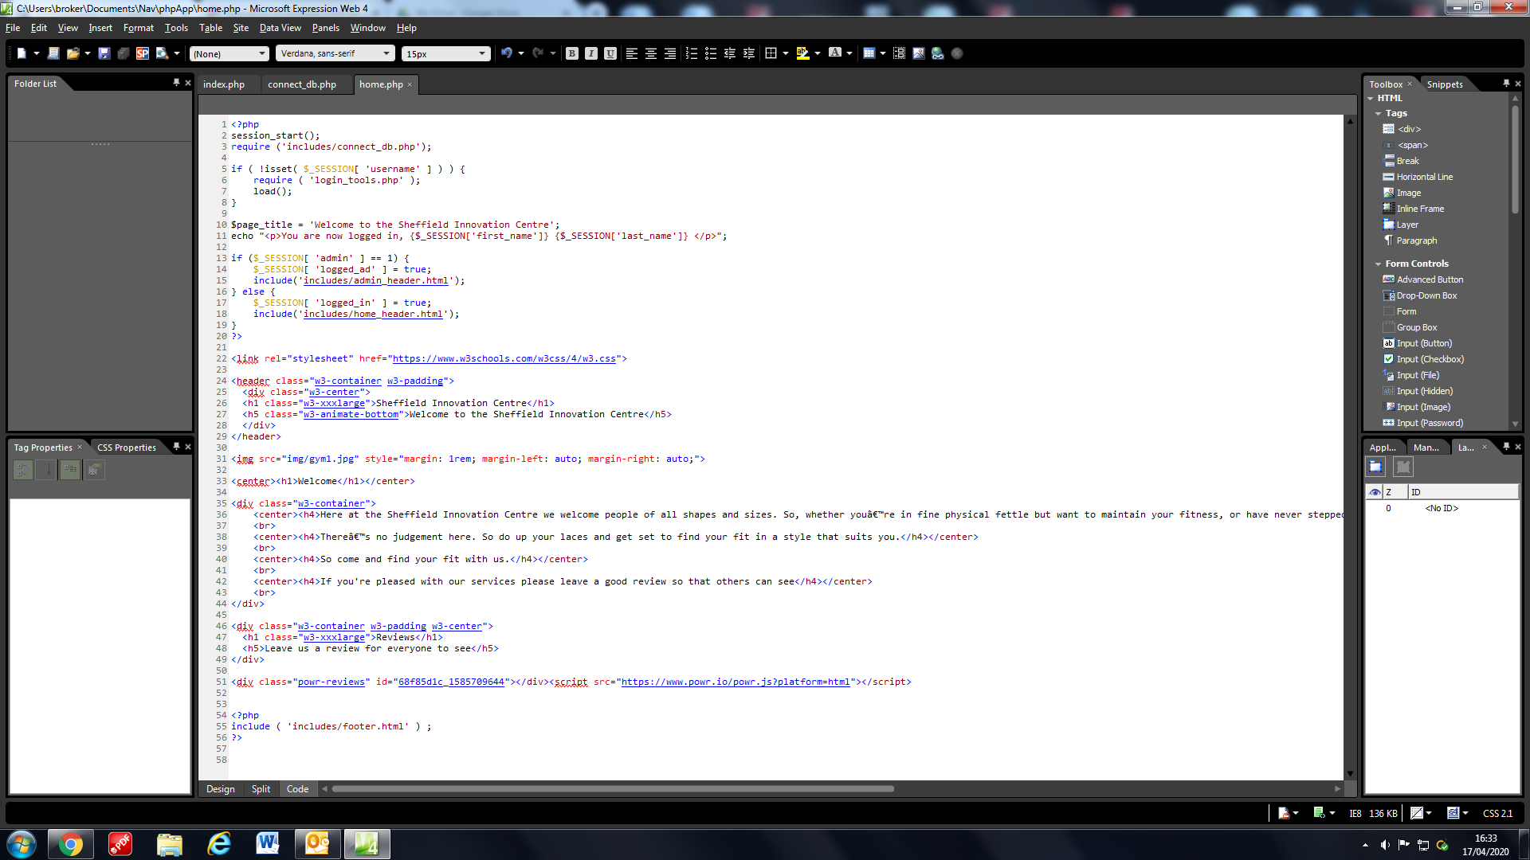

What this function does is it first checks if the username variable from the login_action section of codeis empty if it is then it will load the login_tools code. This is just a form of validation to make sure the page can run. Then it outputs the confirmation of logging in line which includes the two global variables from the login_action which will formulate the first name and last name of the user, which it extracted from the database. The home page is for the use of the users and the admins only.

**Register Page**

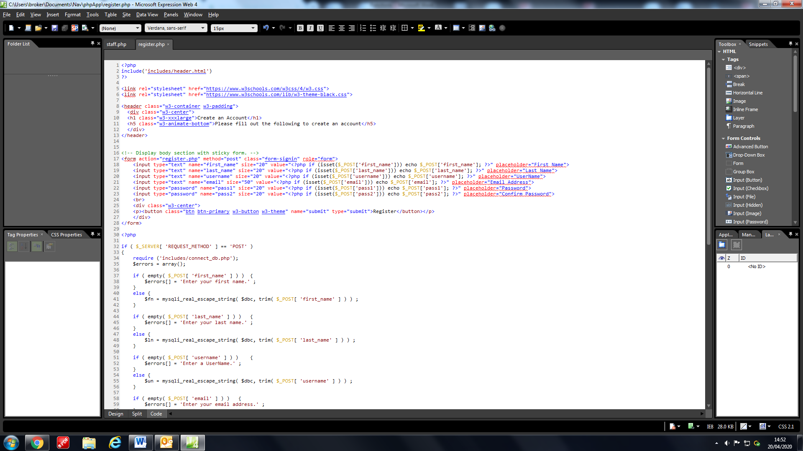

Adding this html form to the page allows the user to enter in their details that will be added to the users table.

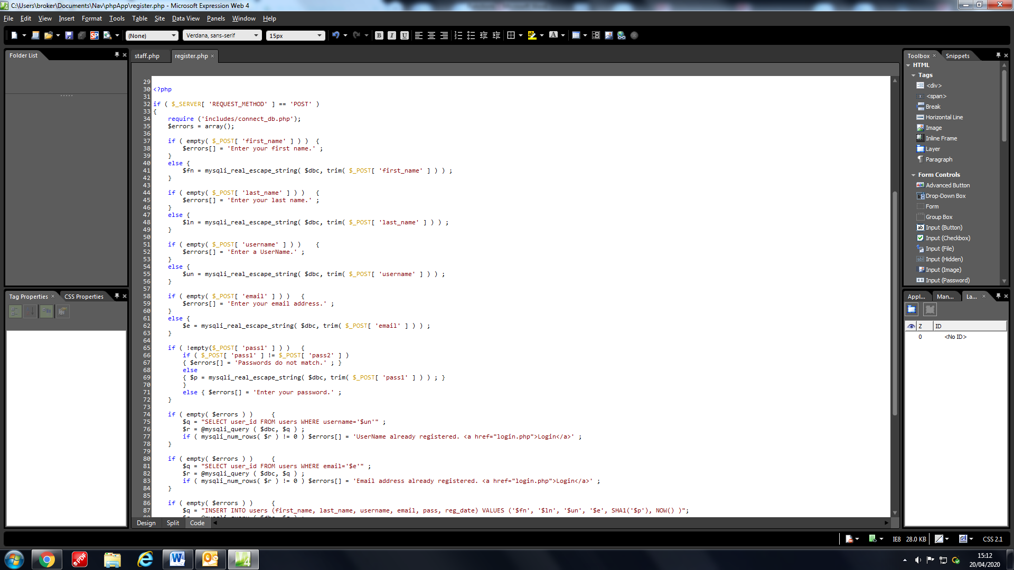

This is a php validation function that makes sure all fields of the form are valid. If it is not empty then it will assign what is in that field to a variable. If it is not valid then it will add a string to an errors array that corresponds to why the field is incorrect. It also checks if the password and confirm password fields are the same. The function gains the information thanks to the php values written in the form. These allow the values within the form to be passed from the html to the php.

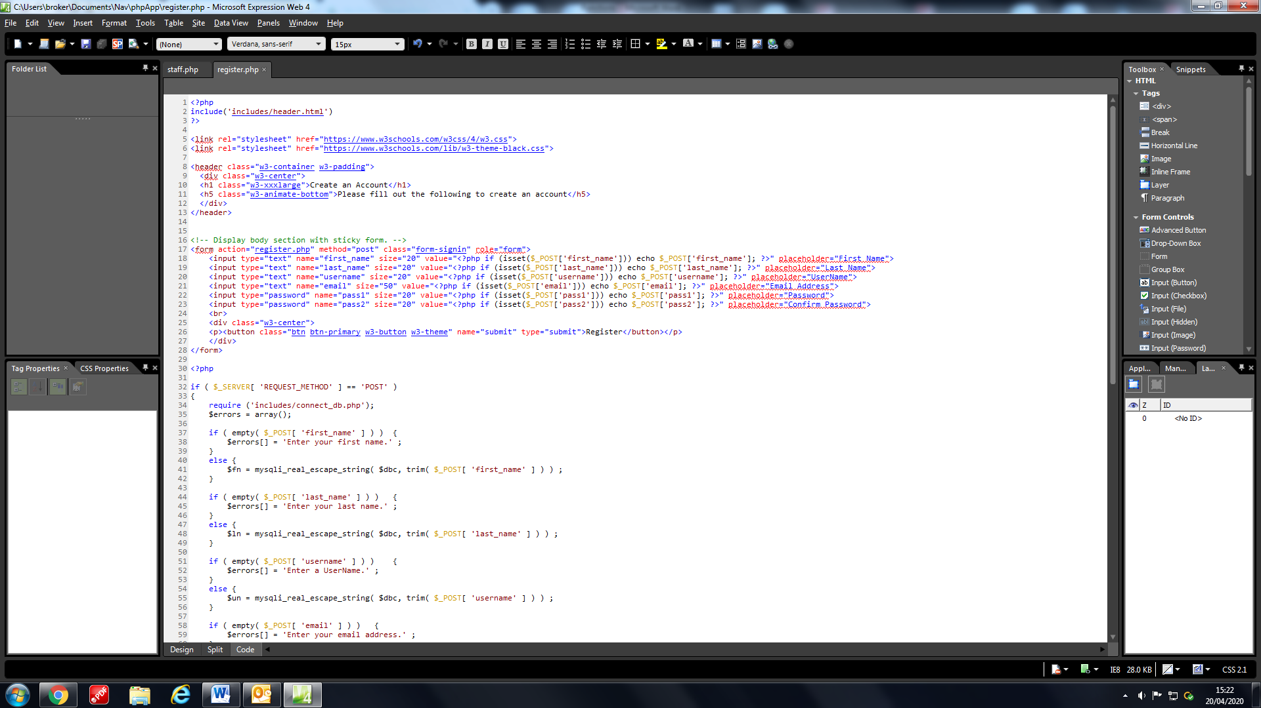

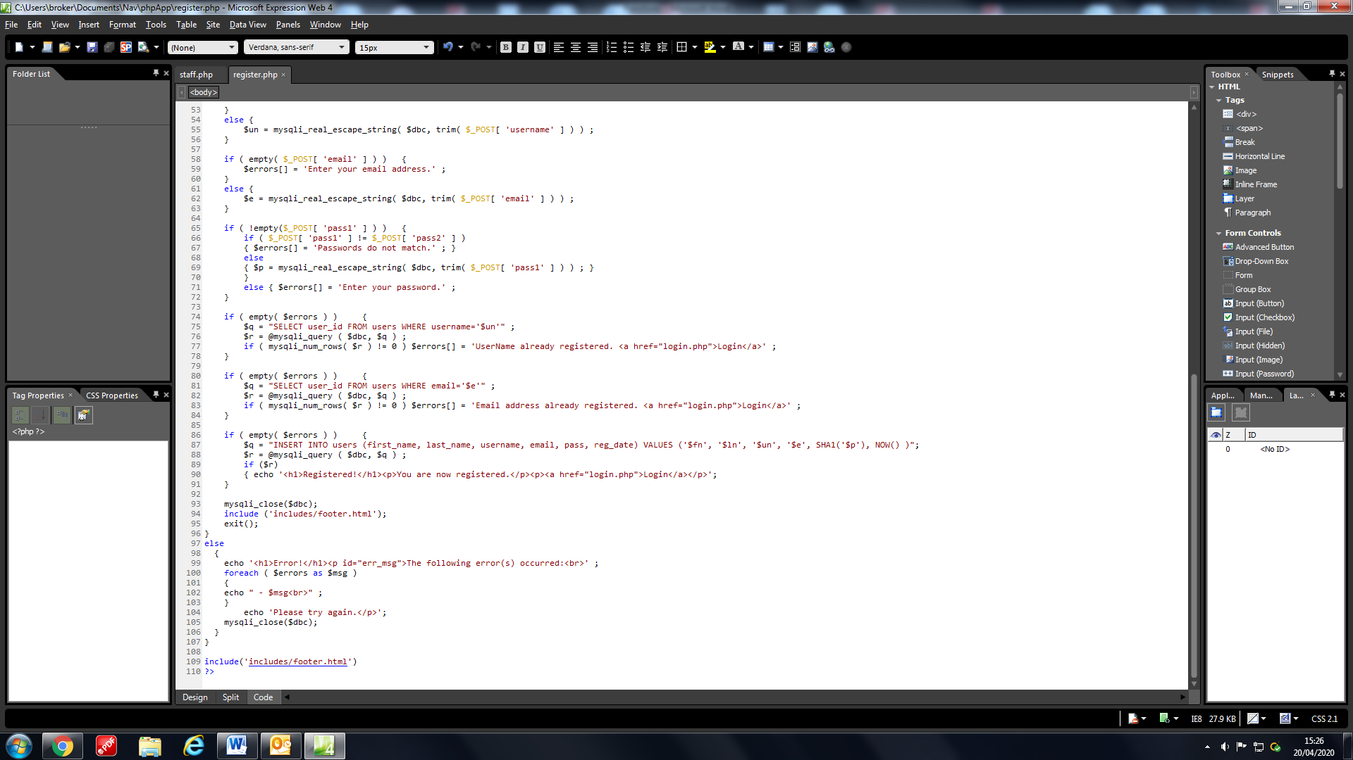

If the errors array is not empty, then the next part of the function using more validation it checks database if the username and email already exist and gives a link to the login page. If the errors array stays empty then it inserts the users details into the database and now allows them to login, however if the array is not empty then the algorithm will display all the fields in the array to the user to let him know why they could not register. Notice how in the Insert SQL statement before the p variable SHA1 is written, this means that the program will hash the variable so that it changes when it enters the database. This is done in order to ensure that if the database is ever hacked then the hacker still will not be able to know the password because when you hash something it is not easily reversible.

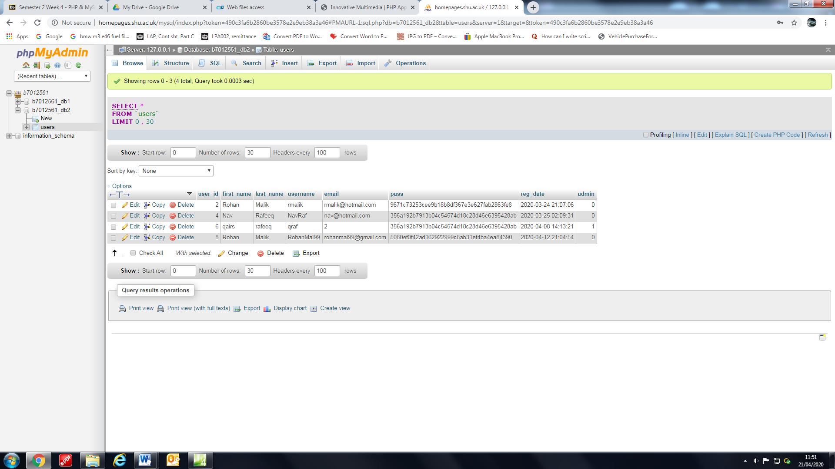

**Login Page**

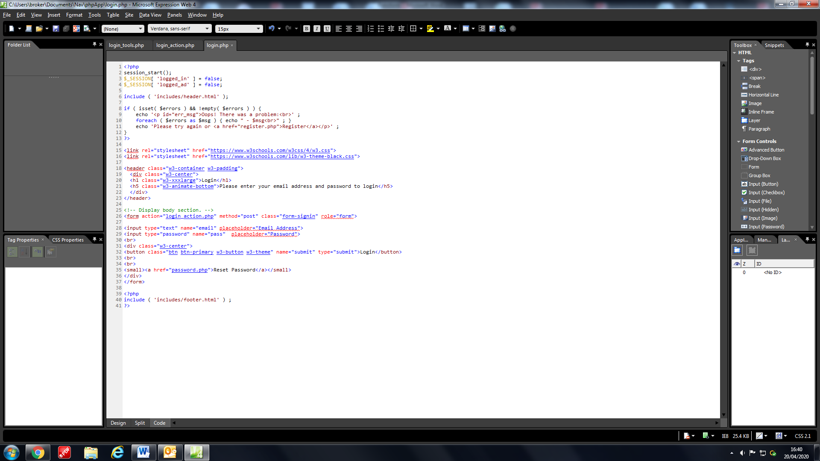

There are 3 php files that work on the login section; the first is login.php that contains the visuals for the login page since it is the one with html in it. The html form has two fields, a submit button and a change password link.

The login_tools.php file contains 2 functions that serve different purposes.

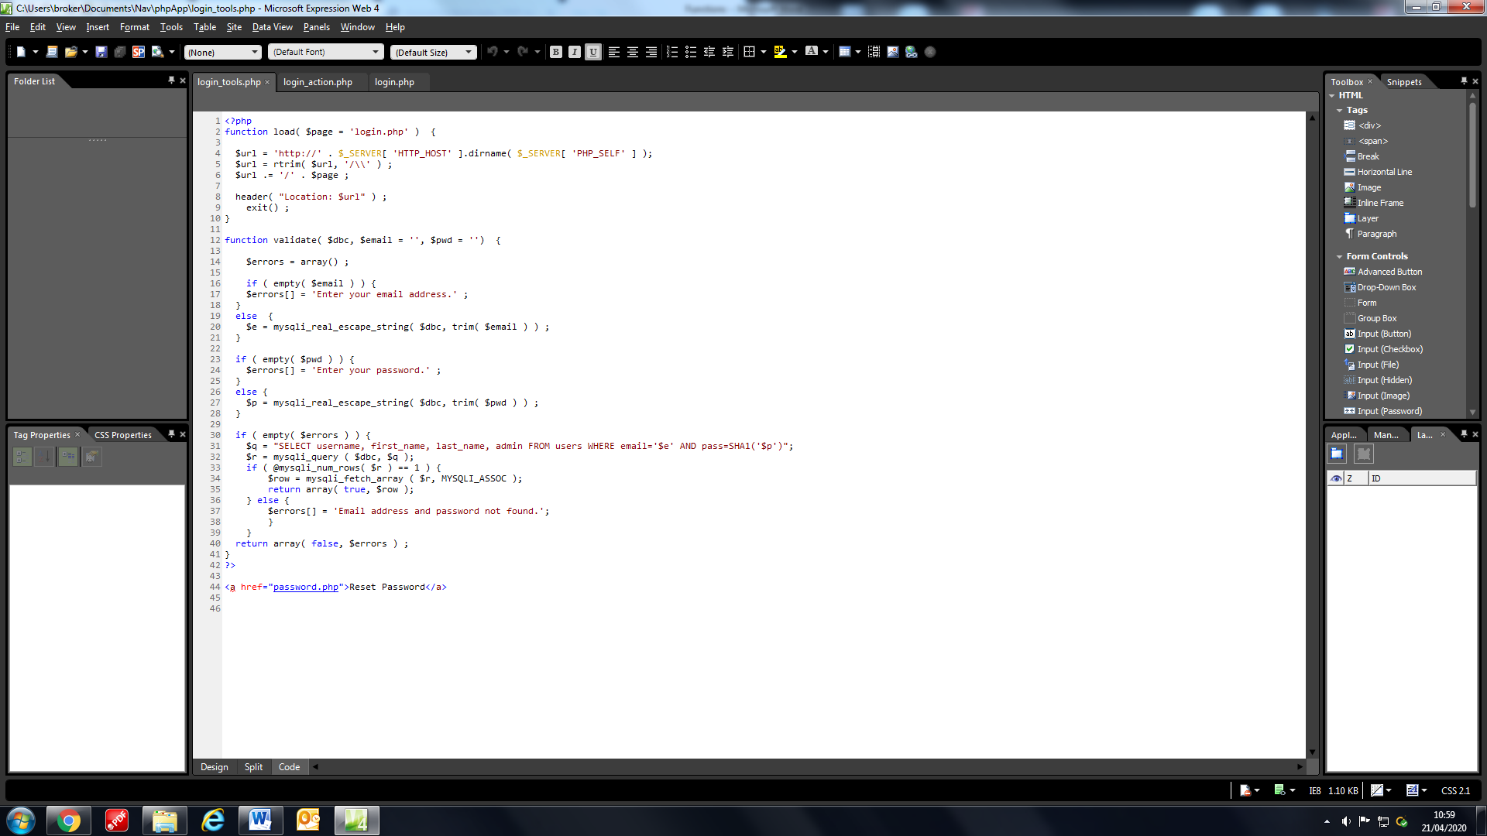

The first function is called load and it will do what is says by loading a new page if required. It saves the login.php as a string into the page variable. Then it builds a URL string of protocol, current domain and directory. It then removes all trailing slashes and adds a new one to go along with the page variable to be added on the end. Finally, it redirects to the URL created and then exits the function. So now any time we wish to use this function in the program we can just write load().



The second function is called validate and it passes through the dbc from the dbconnect.php file so it can establish a connection, it also passes 2 more variables email and pwd . Then, it creates an empty array called errors. We then use this array to collect any errors from if statements if the fields from the login page are empty. If they are not then it adds them the e and p variables respectively and makes sure no special characters are in the names or password so that it does not upset the SQL statement below. If the errors array is empty then it retrieves the username, first name, last name and the admin fields from the row where the email is equal to the variable e and where the password is the same as the one in the database (this is done thanks to the hashing key). If there is only one row then you know the email address and password are correct and it returns the data in the row. If the SQL query returns with anything but one row then it will add an error to the errors array. Finally, if the errors array is not empty then it will output the errors and not return the data from the database.

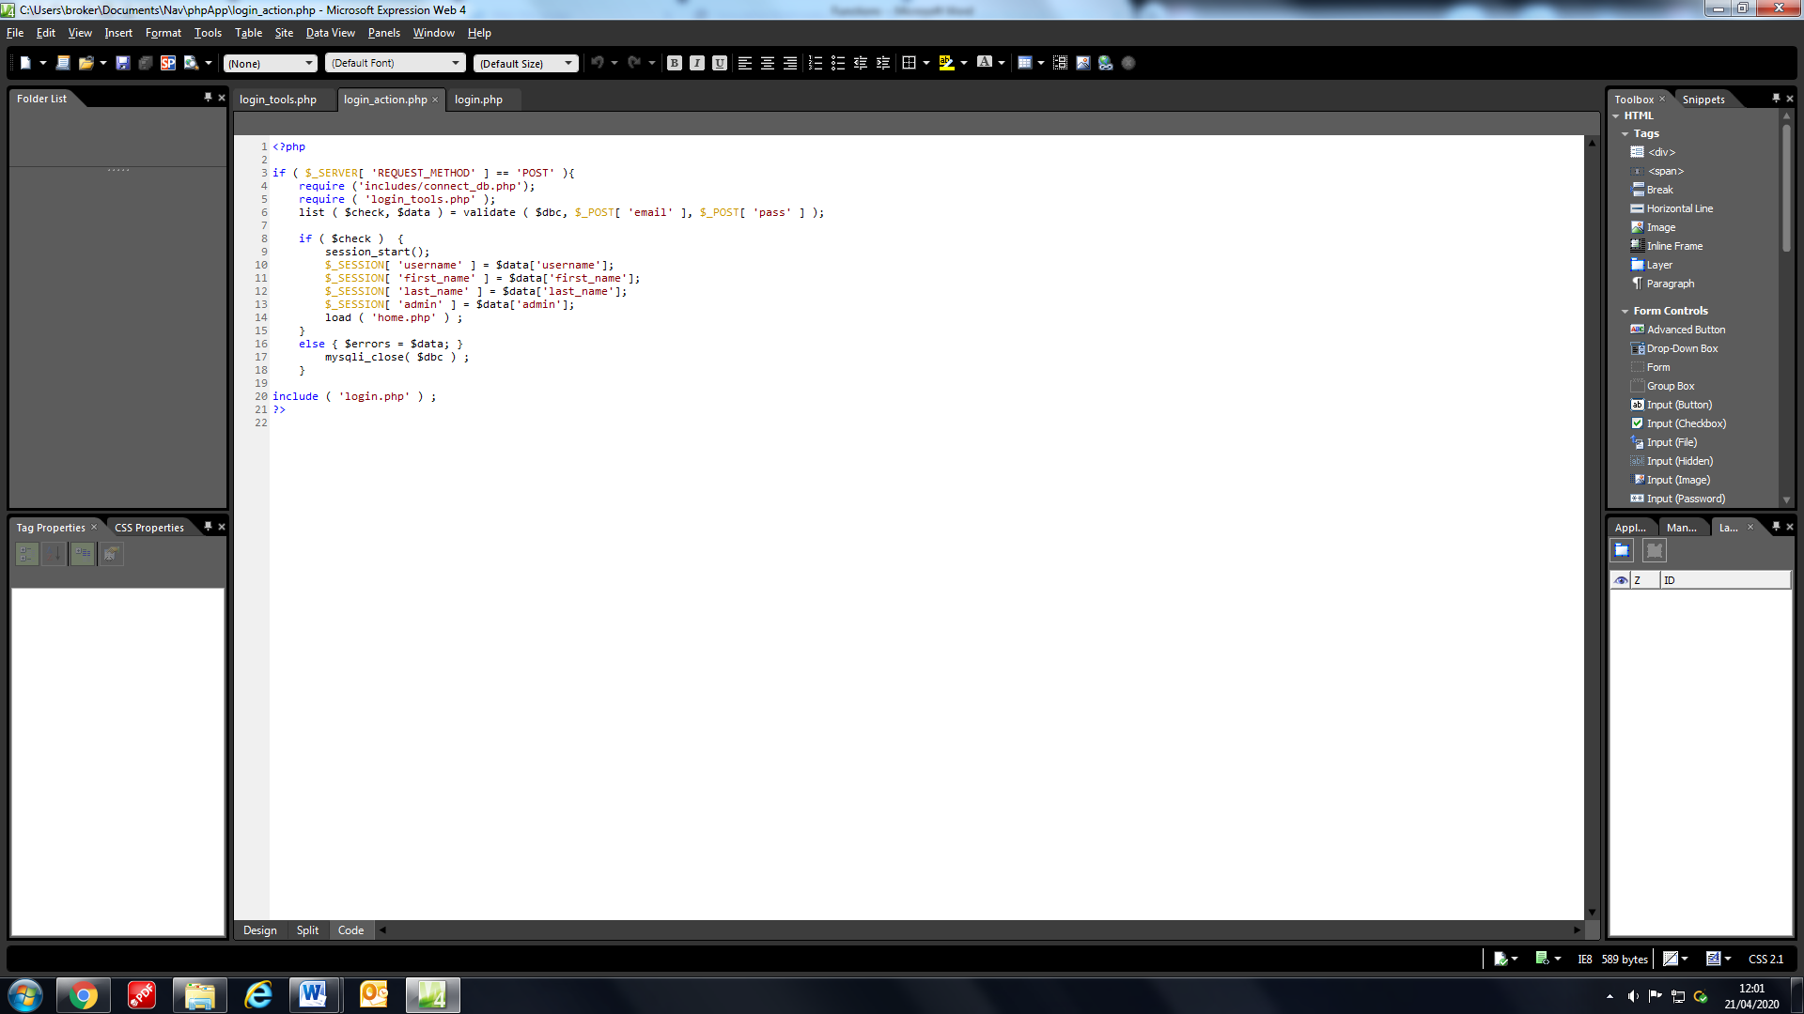

The next file is the login_action.php file. It works when the login page login button is clicked, it obtains the validate function from login_tools and creates global variables with the users details to be used later. Once done it uses the load function from login_tools and passes through its own string home.php therefore, loading the home page when the user logs in with the correct details. These details are used to determine whether the user is an admin and also to gain information on the user that has logged in. This is how we wrote that bepoke message on the home page.

**Membership Page**

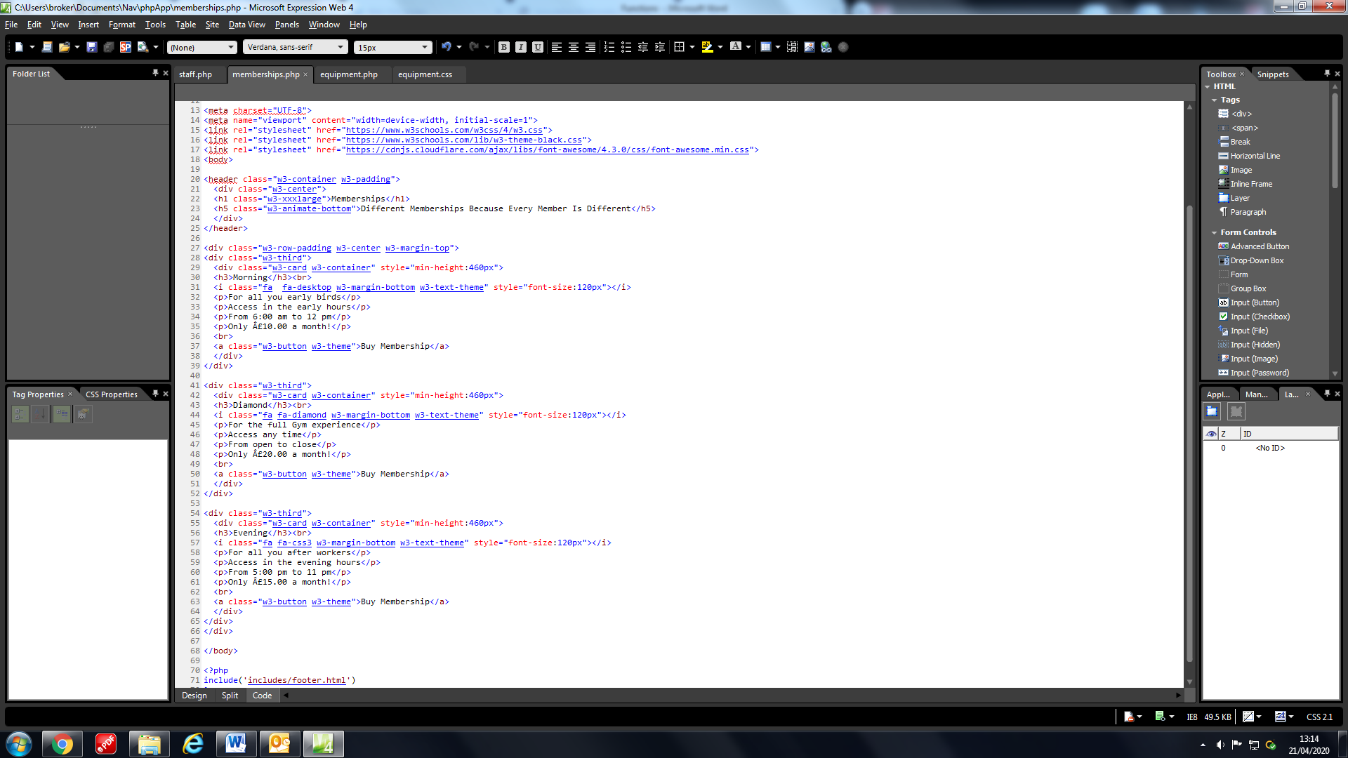

As said before by using css links from w3schools it is easier to edit the website appearance. By giving classes w3 names it can change the format of objects and texts.

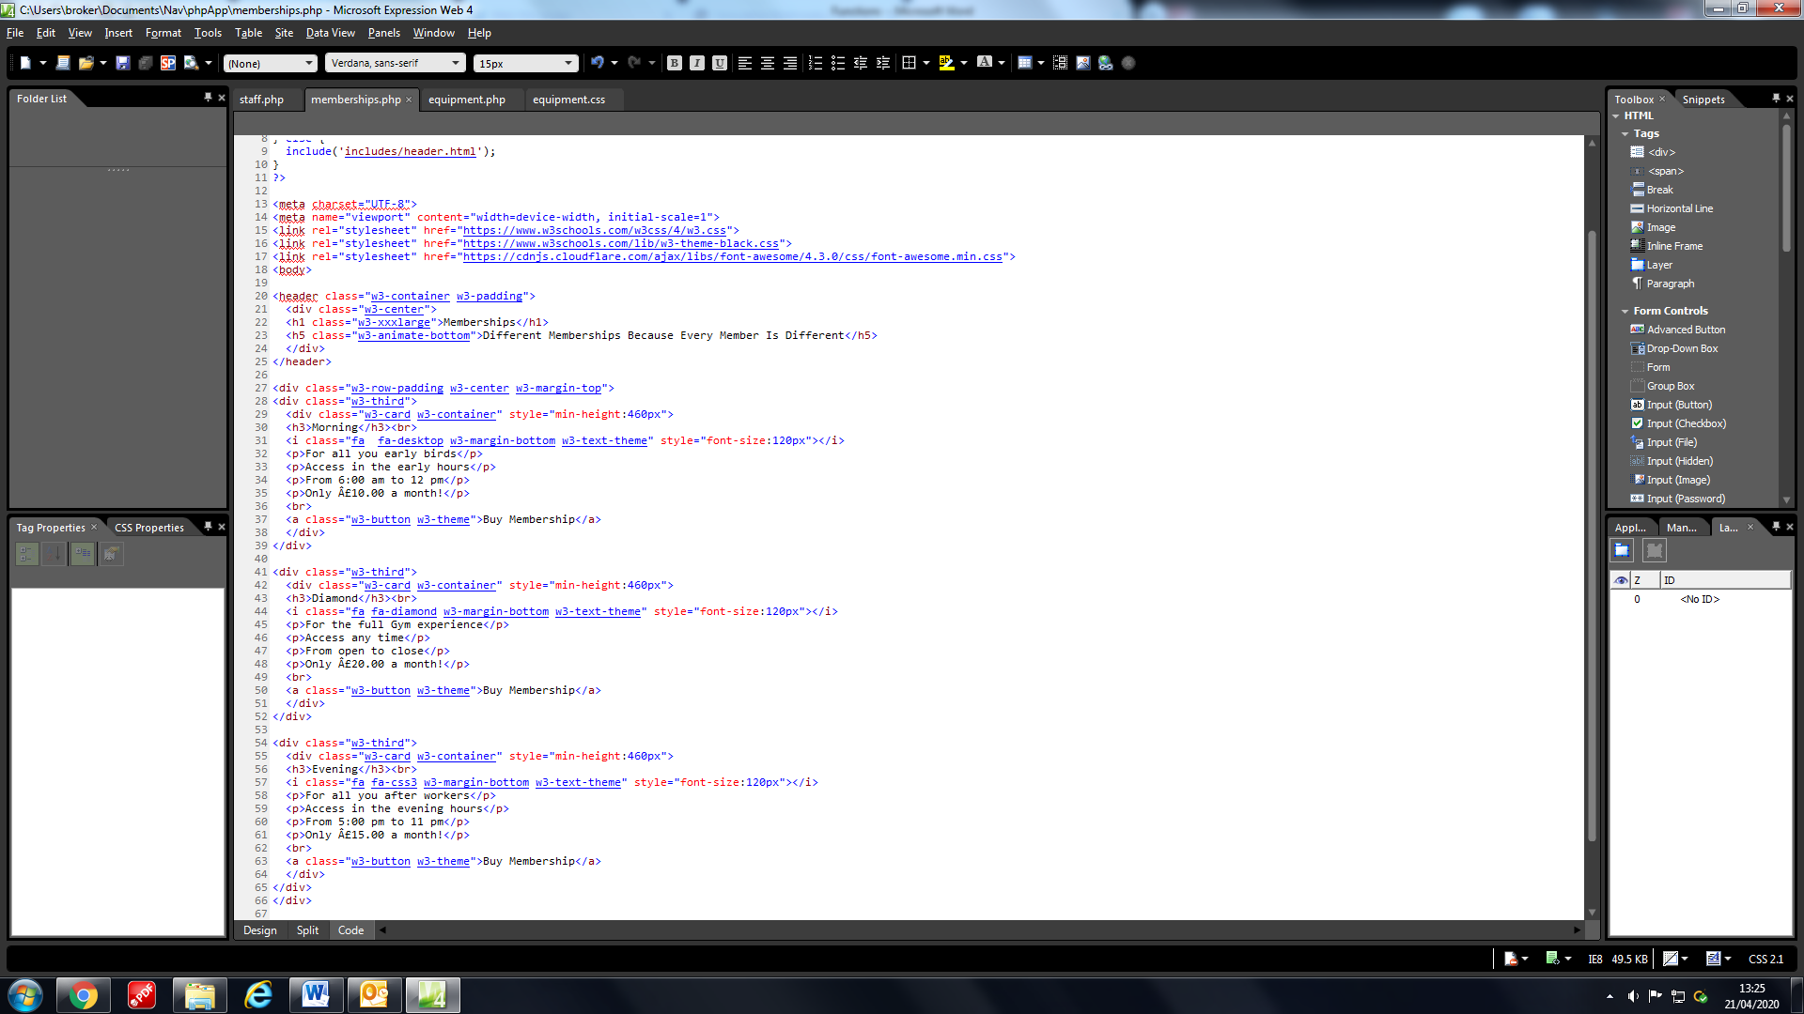

By using HTML and CSS 3 divs were made that all became their own cards with their own memberships. Since this is a prototype the buttons do not do anything however, as you have seen with the log in system we can easily implement changes to occur for a user as soon as we add a buy system for the full website.

**Staff Page**

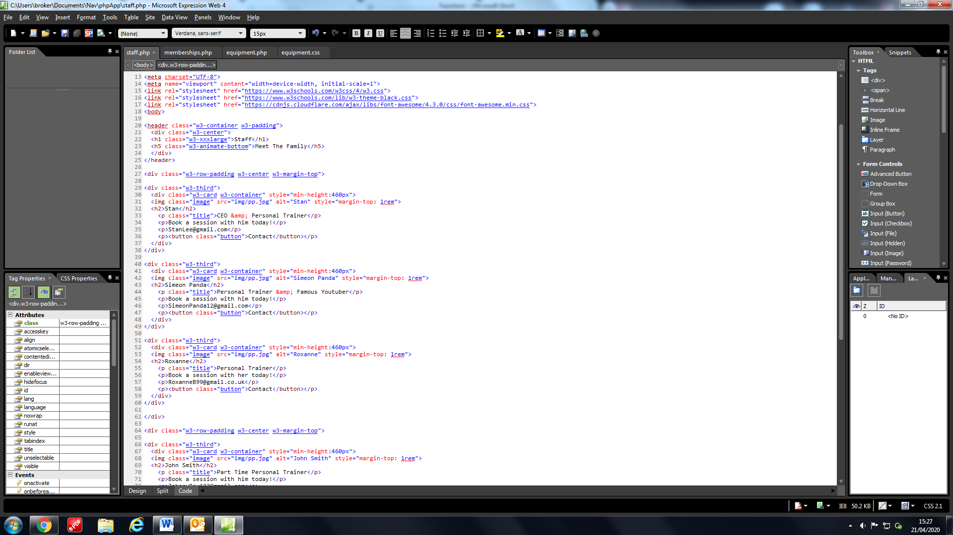

The Staff page, like the Membership page, also has cards which contains information of a personal trainer with an image and a contact button. It is split up to 3 cards per row with more cards that can be added when more staff members join the gym. As each staff member joins their pictures can replace the prototype pictures that are there currently by replacing the “img/pp.jpg”.

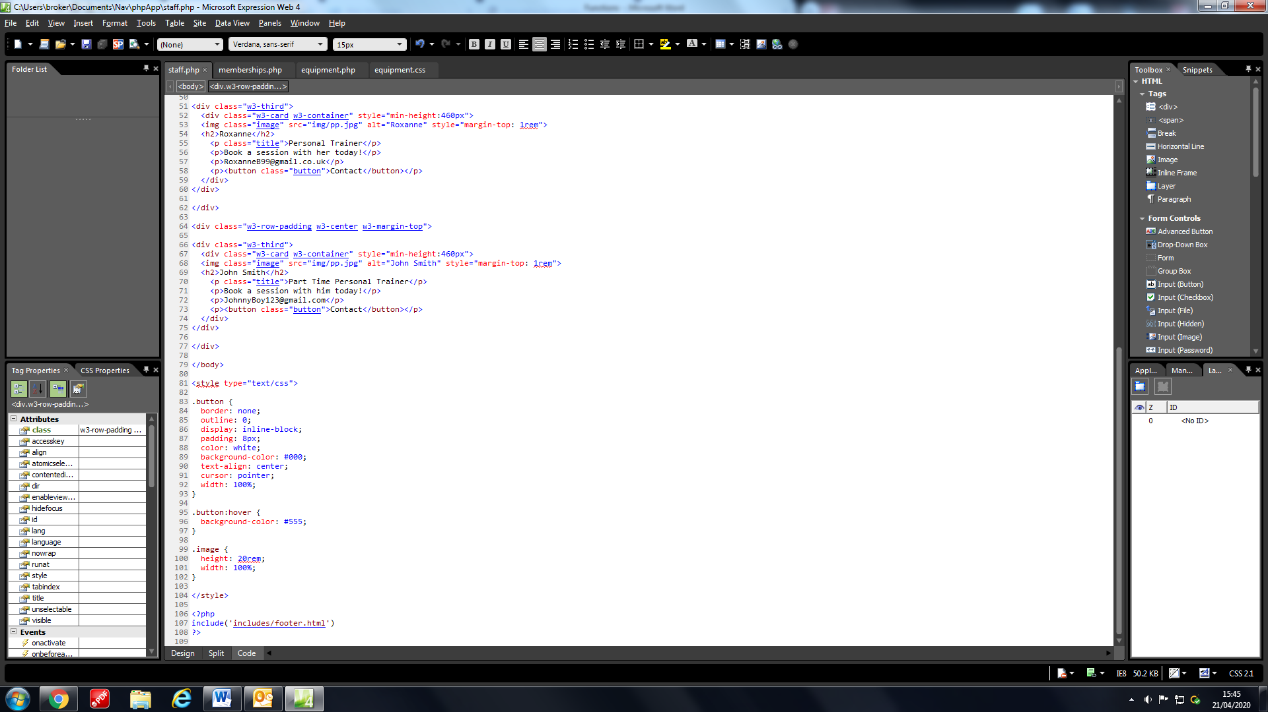

At the end of the file some CSS was added in order to make sure the cards looked clean and matched the theme of the website.

**Equipment Page**

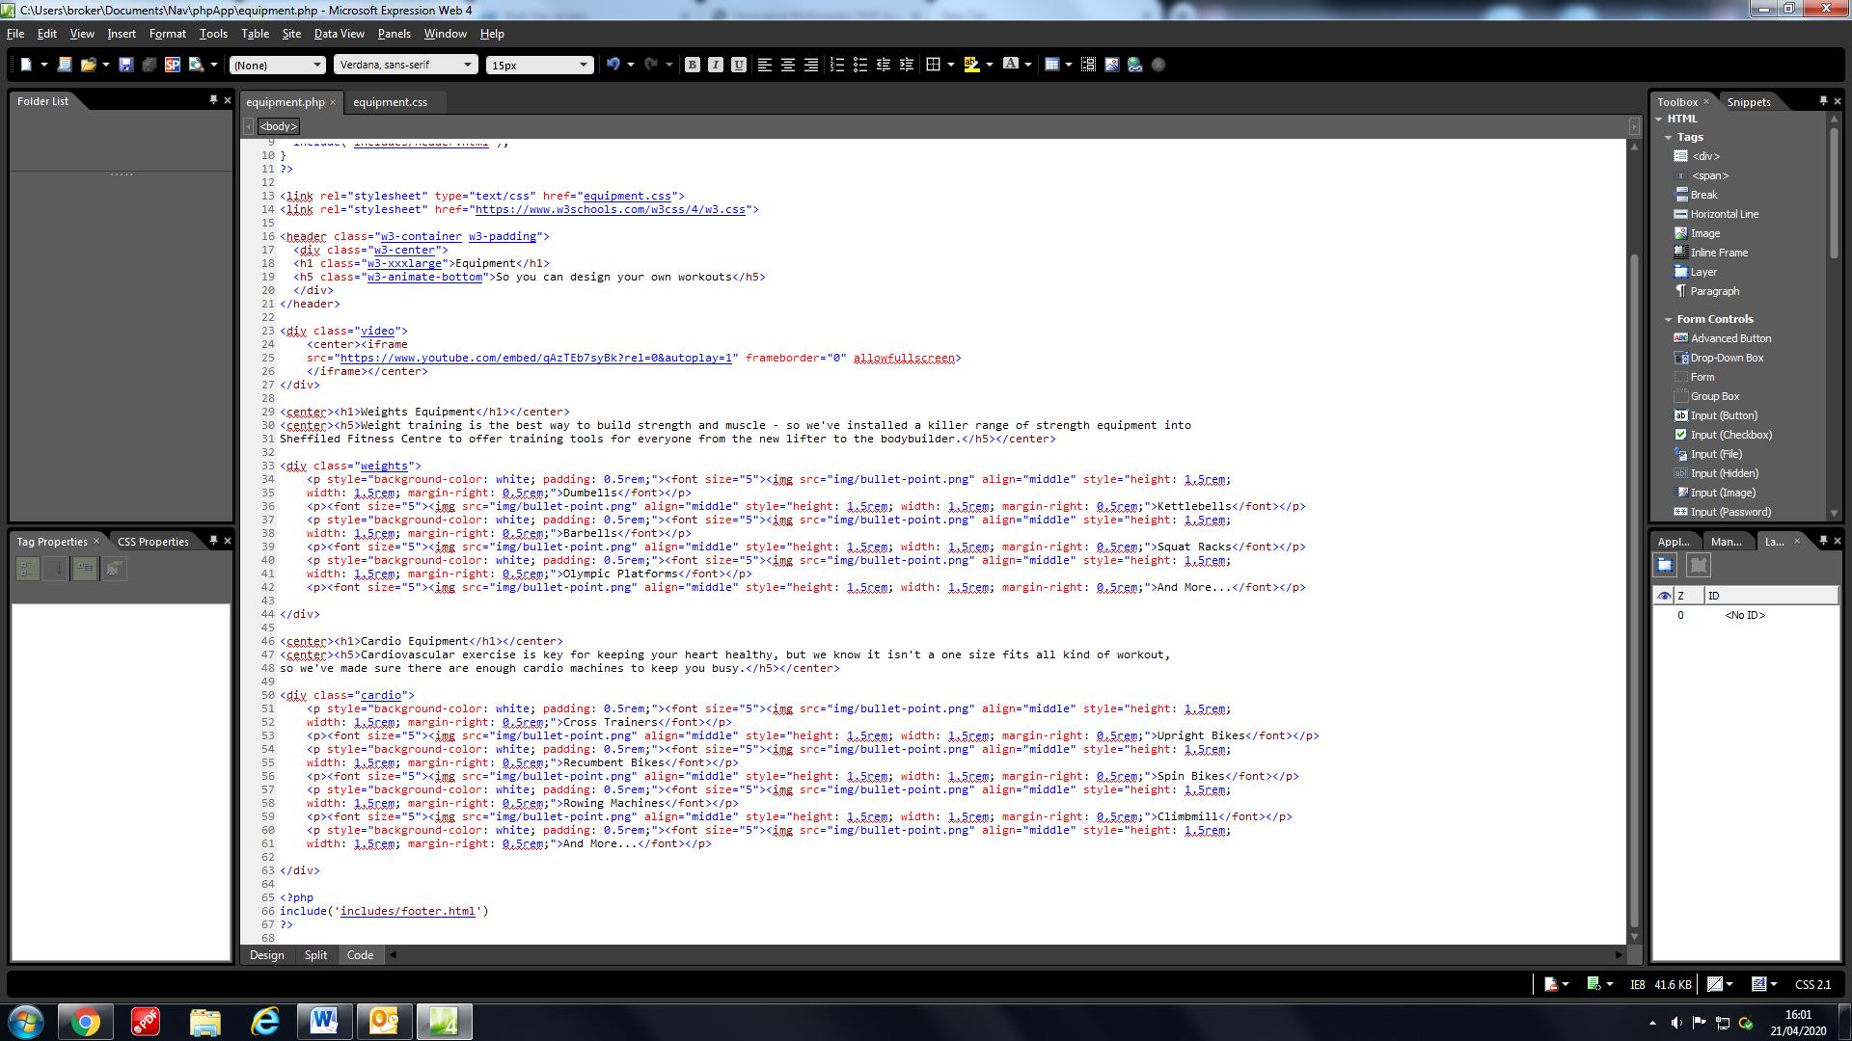

The equipment page starts off with a video from YouTube that automatically plays informing the user on how use certain gym equipment.

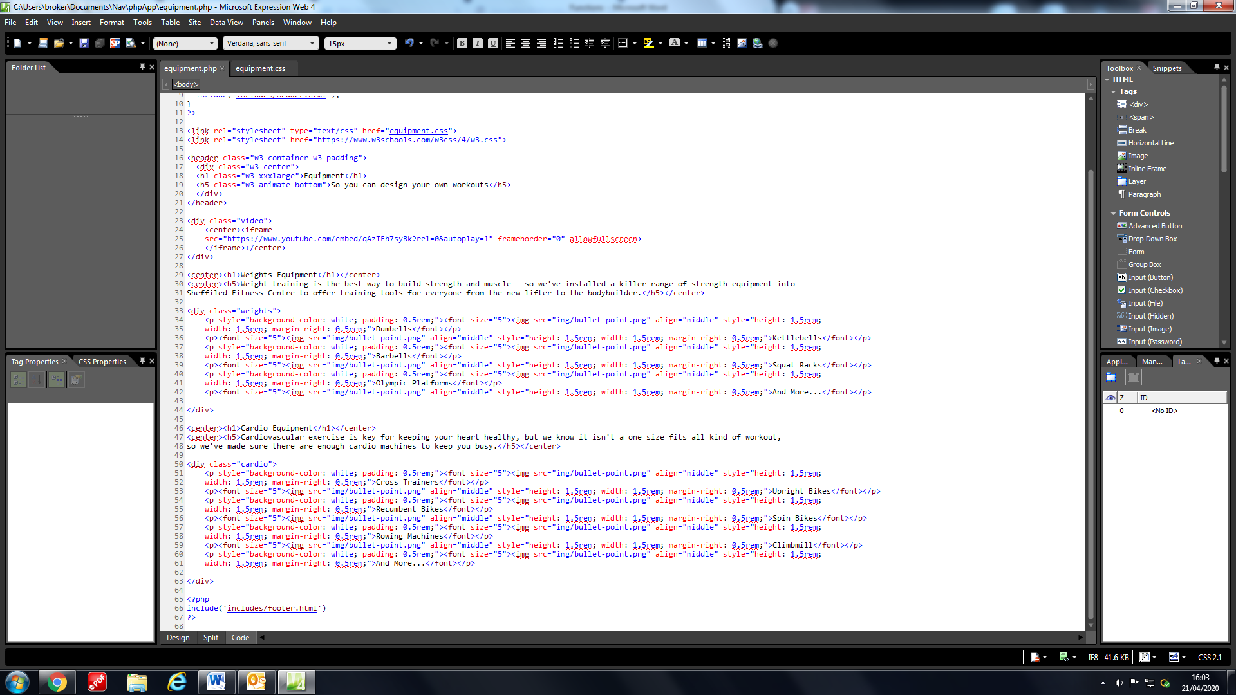

Then a description of each type of equipment is given i.e Weight training or Cardiovascular and the user is given a list of all the equipment that relate to that category. Using HTML and CSS we managed to include all the text and images as well as display them in a manner that is easily readable and accessible to the user.

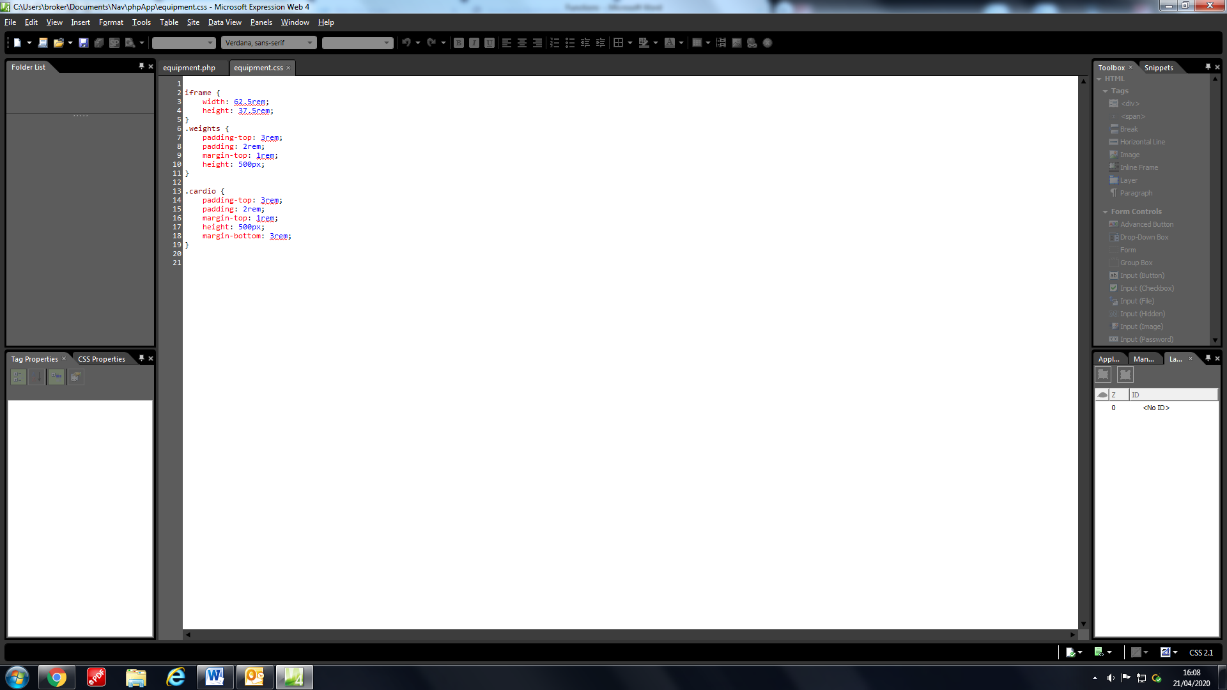The equipment.css file contains classes for the weights and cardio section to make sure the information was spread out across the page in an even manner. The Youtube video size is also determined by this CSS file as well.

**Contact Page**

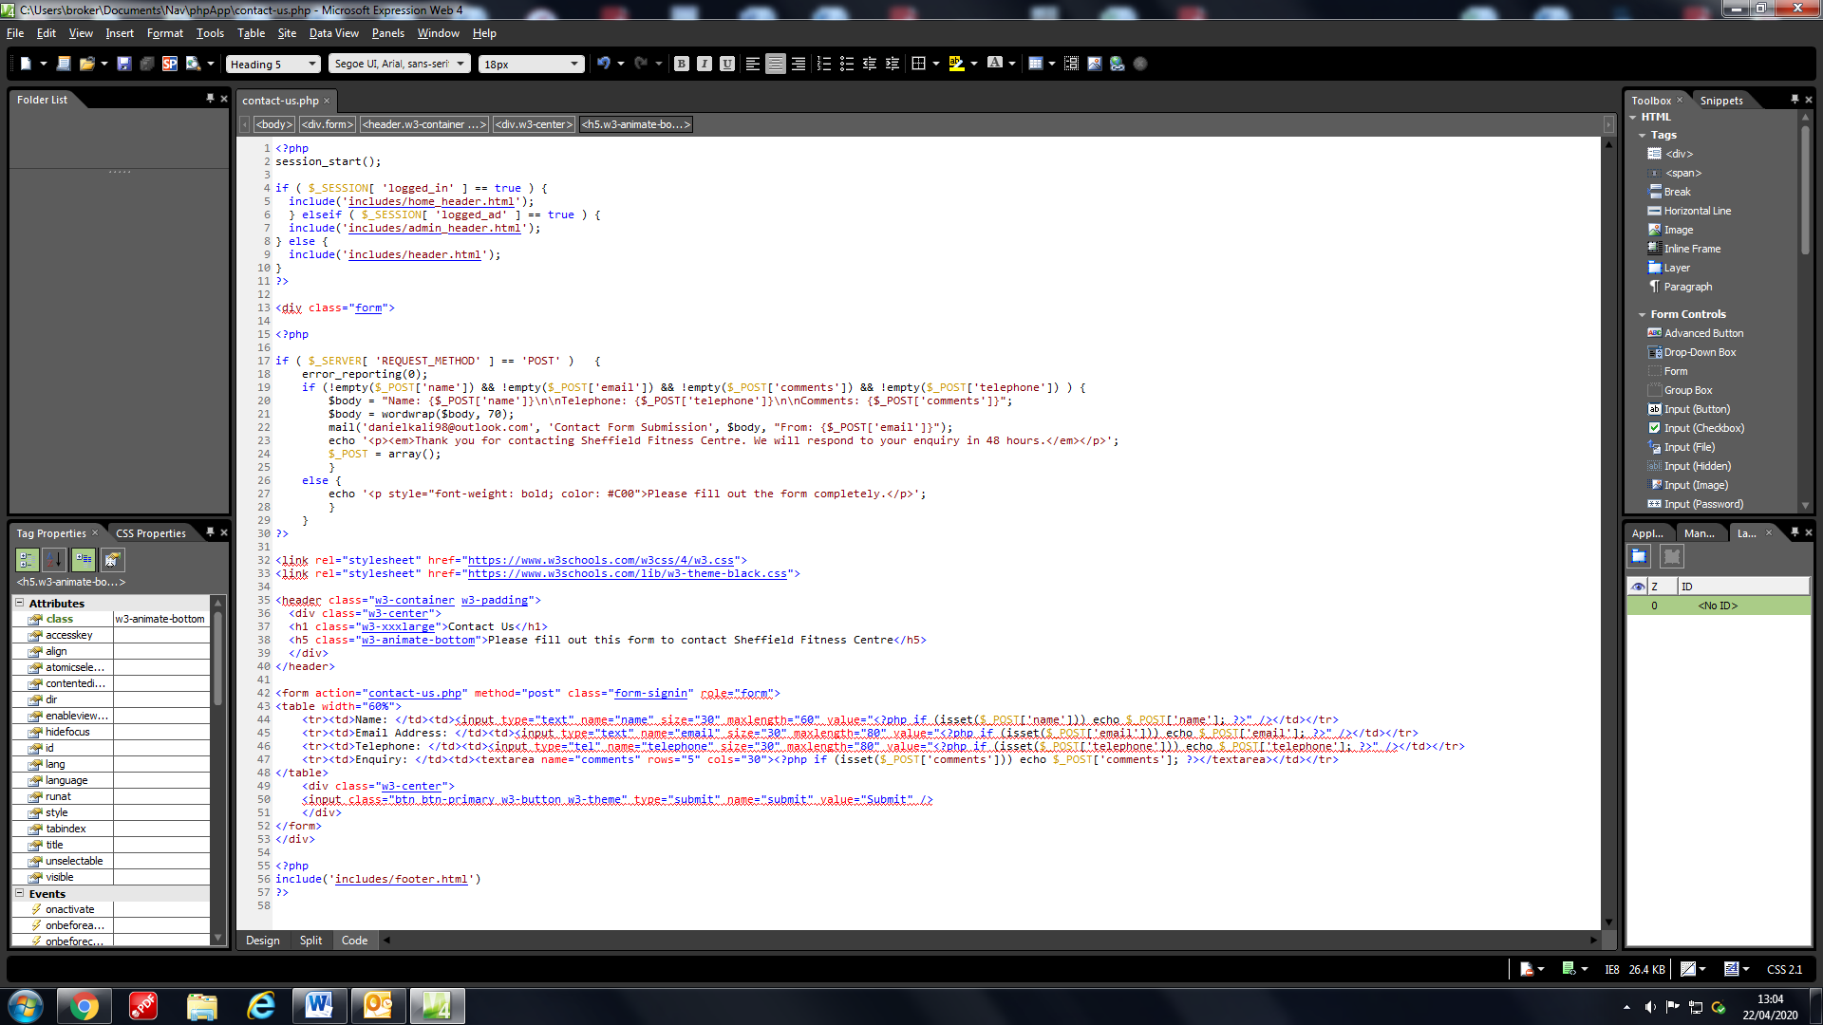

The contact page was created for users to contact the gym staff with any enquiries they had. The HTML form above demonstrates a form that uses PHP to collect the data entered in the fields by the user. The W3 classes allow the form to fit with the theme of the website. These PHP values are then passed on to this IF statement.

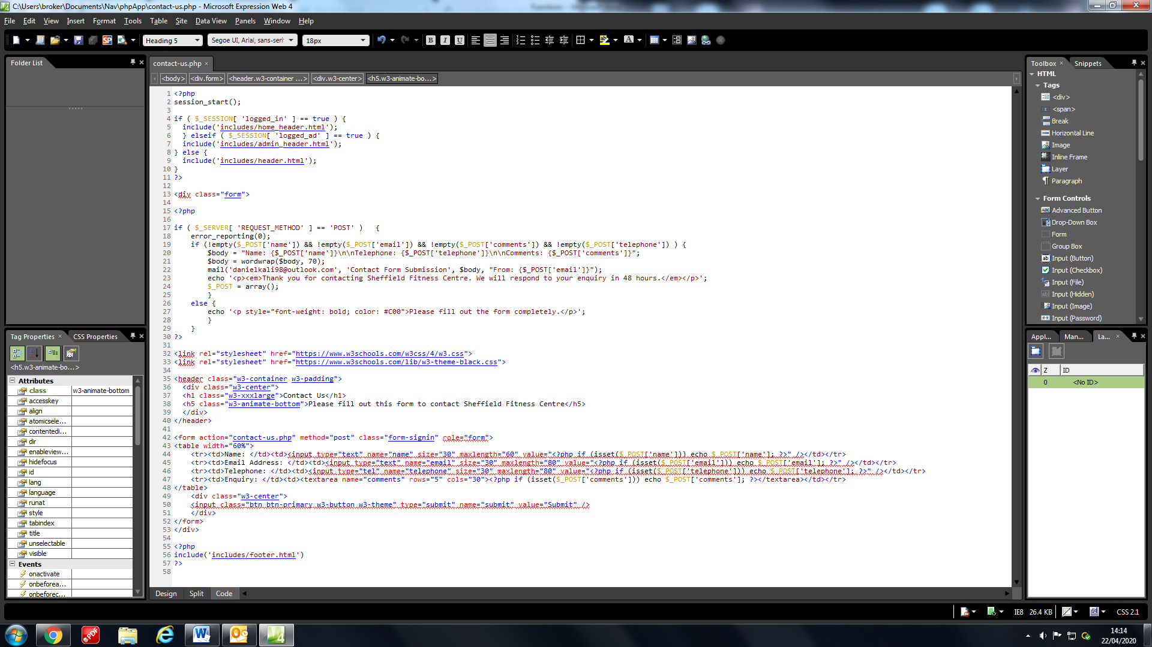

It obtains the data and checks if any of the fields are empty, then it writes out the body of the email that contains the users name, email, telephone number and enquiry. It then saves it to a variable so it can be mailed to the staff enquiries email when the button is clicked. It then displays a message to the user informing them that the enquiry has been sent.

**Admin Page**

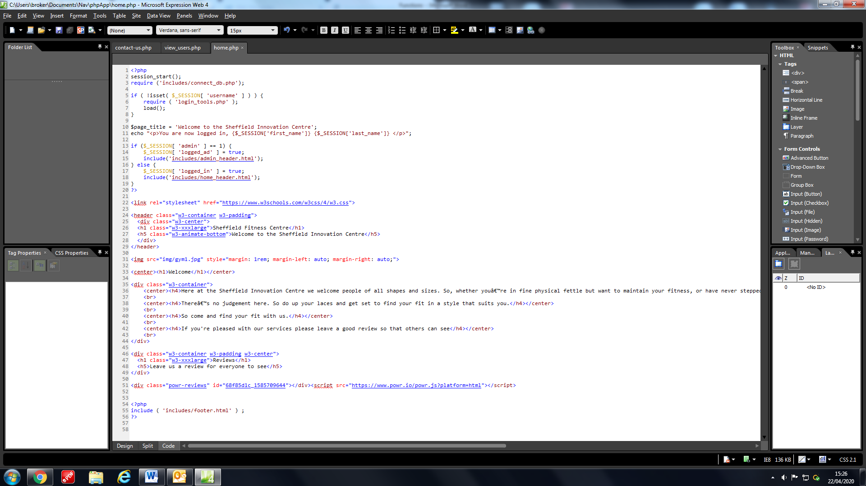

This IF statement in the home page determines whether an admin has logged in or if it is just a regular user.

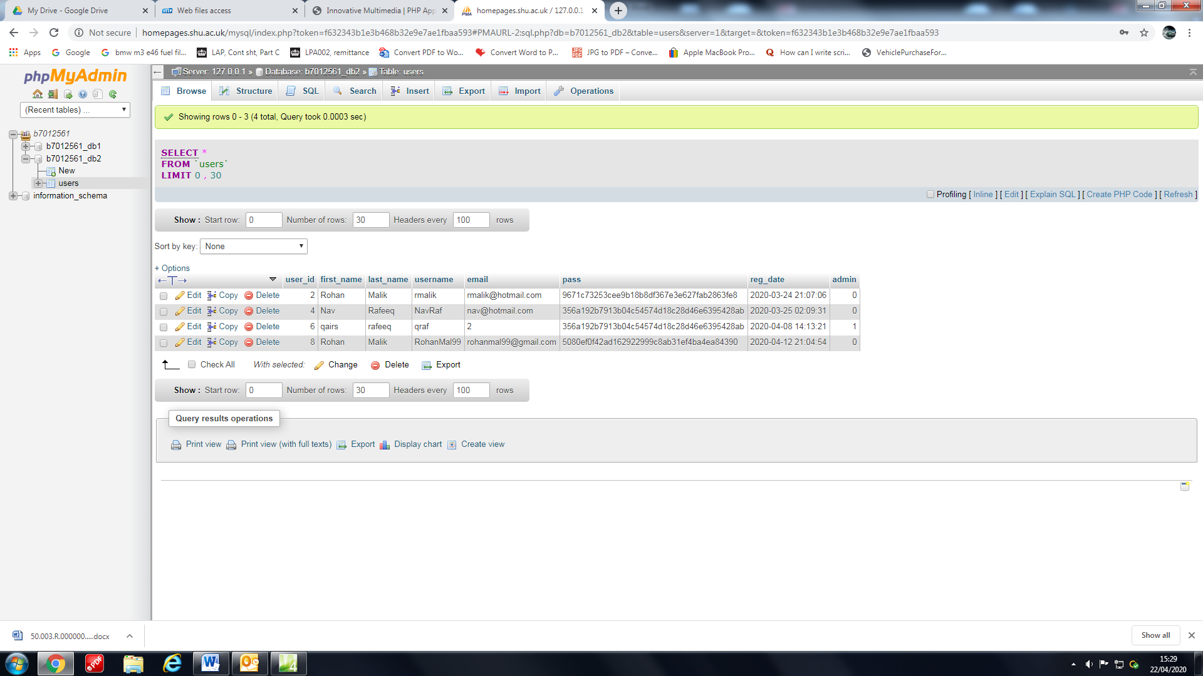It does this by looking at the admin Boolean column that either has a 1 if it is true and a 0 if it is false. So if the admin column is equal to 1 it loads the admin header which contains the view_users.php page.

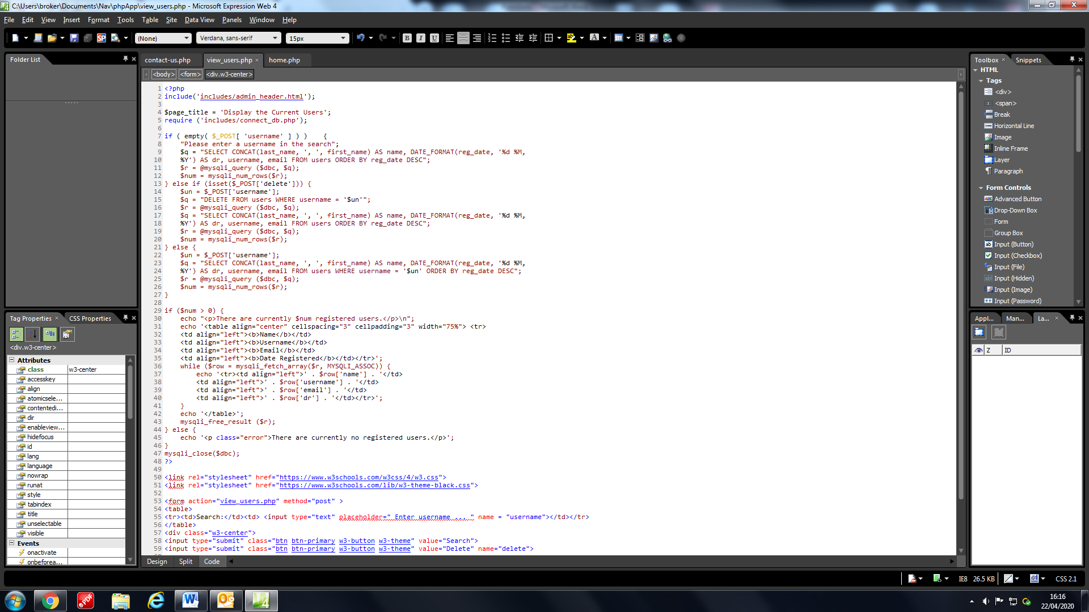

It starts with an IF statement that performs and SQL search that displays the name, username, email and date registered of all the users and orders it with the newest first. It does this because the search bar is empty, if the search bar is not empty then it searches the user via username and displays their data only and if you wish to delete the account then it can be done so by clicking the delete button.

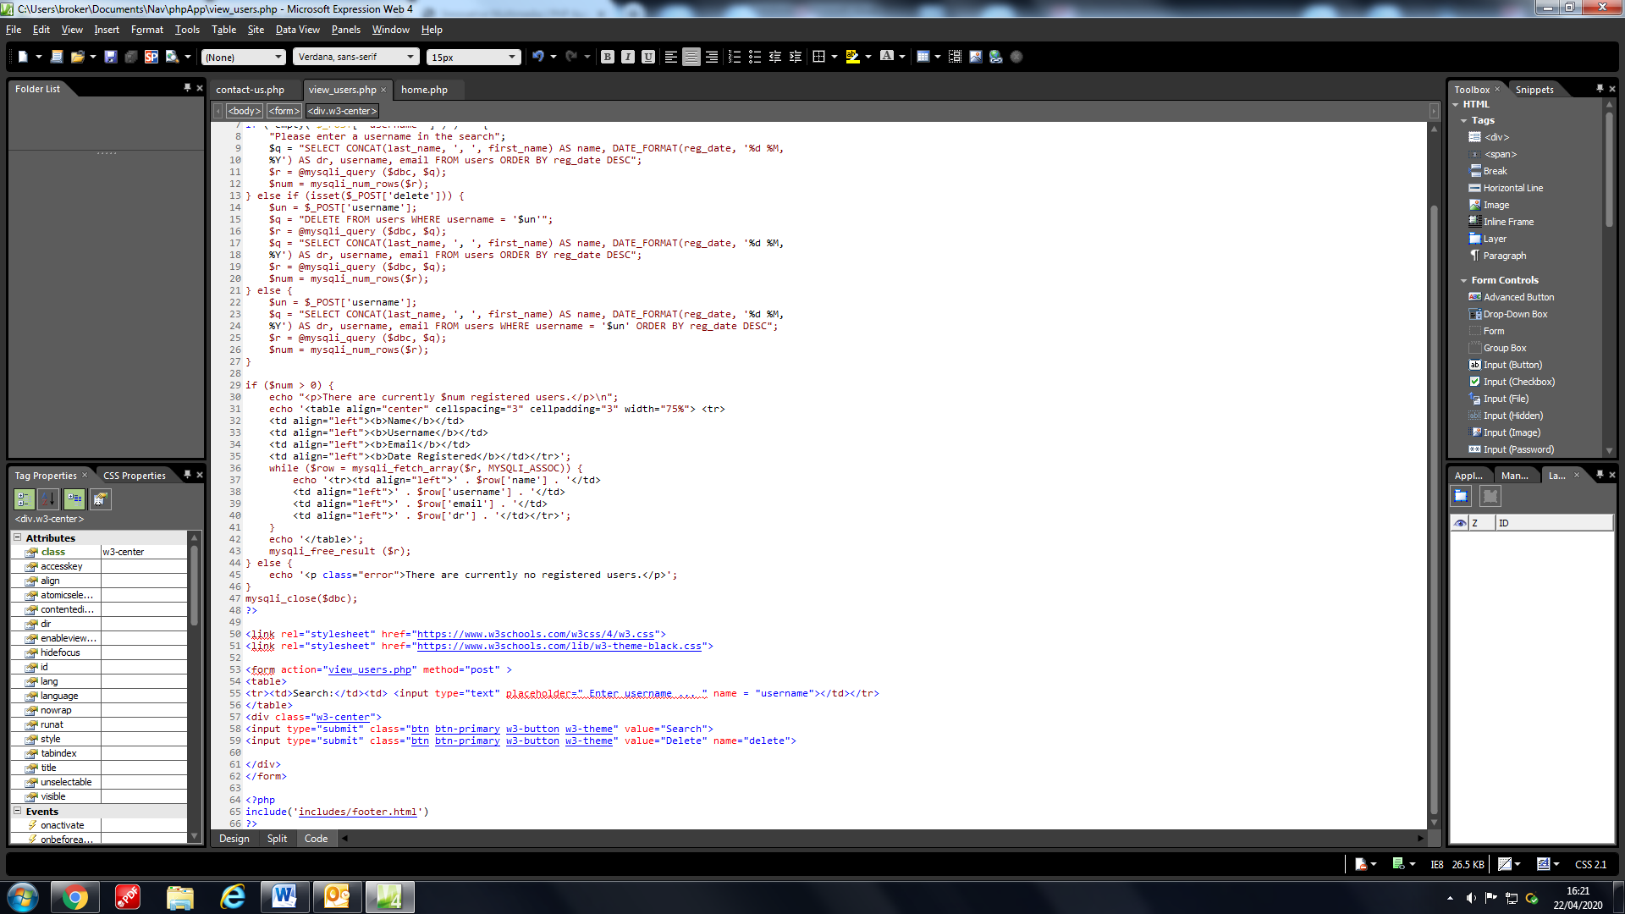

This IF statement creates a table using HTML and CSS but also uses a PHP while loop in order to fill out all of the rows of the table, it also tells the admin how many users are registered.

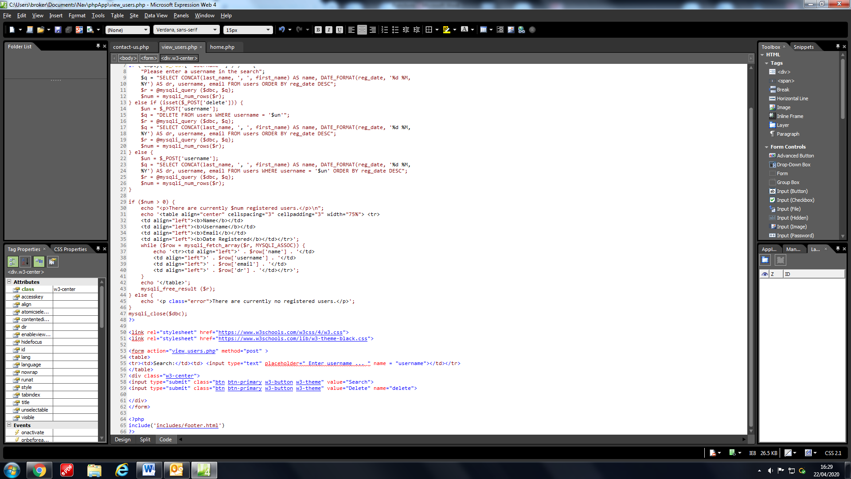

When either of these buttons in the HTML form is clicked the page reloads and thus performs the page IF statements again, this is how the page changes the display of users within the table shown.

**Change Password**